**VISVESVARAYA TECHNOLOGICAL UNIVERSITY**

**“JnanaSangama”, Belgaum -590014, Karnataka.**



**LAB REPORT**

**on**

Object Oriented Modelling and Design

***Submitted by***

**Sushma T P (1BM20CS416)**

***in partial fulfillment for the award of the degree of***

**BACHELOR OF ENGINEERING**

***in***

**COMPUTER SCIENCE AND ENGINEERING**



**B.M.S. COLLEGE OF ENGINEERING**

**(Autonomous Institution under VTU)**

**BENGALURU-560019**

**April-2022 to July-2022**

**B. M. S. College of Engineering,**

**Bull Temple Road, Bangalore 560019**

(Affiliated To Visvesvaraya Technological University, Belgaum)

**Department of Computer Science and Engineering**



**CERTIFICATE**

This is to certify that the Lab work entitled “Object Oriented Modelling and Design” carried out by **Sushma T P(1BM20CS416),** who is bonafide student of **B. M. S. College of Engineering.** It is in partial fulfillment for the award of **Bachelor of Engineering in Computer Science and Engineering** of the Visvesvaraya Technological University, Belgaum during the academic year 2021-2022. The Lab report has been approved as it satisfies the academic requirements in respect of a **Object Oriented Modelling and Design - (20CS6PCOMD)** work prescribed for the said degree.

Dr. Latha N R **Dr. Jyothi S Nayak**

Assistant Professor Professor and Head

Department of CSE Department of CSE

BMSCE, Bengaluru BMSCE, Bengaluru

`

**Index Sheet**

|  |  |  |
| --- | --- | --- |
| **Sl.**  **No.** | **Experiment Title** | **Page No.** |
| **1** | **Coffee Vending Machine** | **4-12** |
| **2** | **Hostel Management System** | **13-20** |
| **3** | **Stock Maintenance System** | **21-30** |
| **4** | **Online Shopping System** | **31-37** |
| **5** | **Railway Reservation System** | **38-44** |
| **6** | **Graphics Editor** | **45-51** |
| **7** | **College Information System** | **52-59** |

**Course Outcome**

|  |  |
| --- | --- |
| **CO4** | **Ability to conduct practical experiment to solve a given problem using Unified Modeling language.** |

**Exercise 1: Coffee Vending Machine**

# SRS

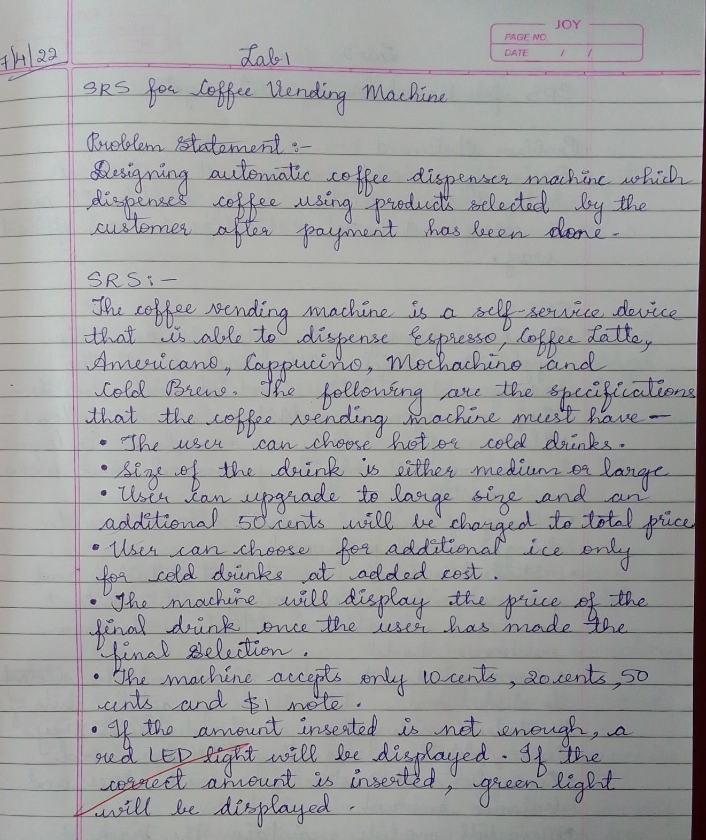

1. **Advanced Class Diagram**

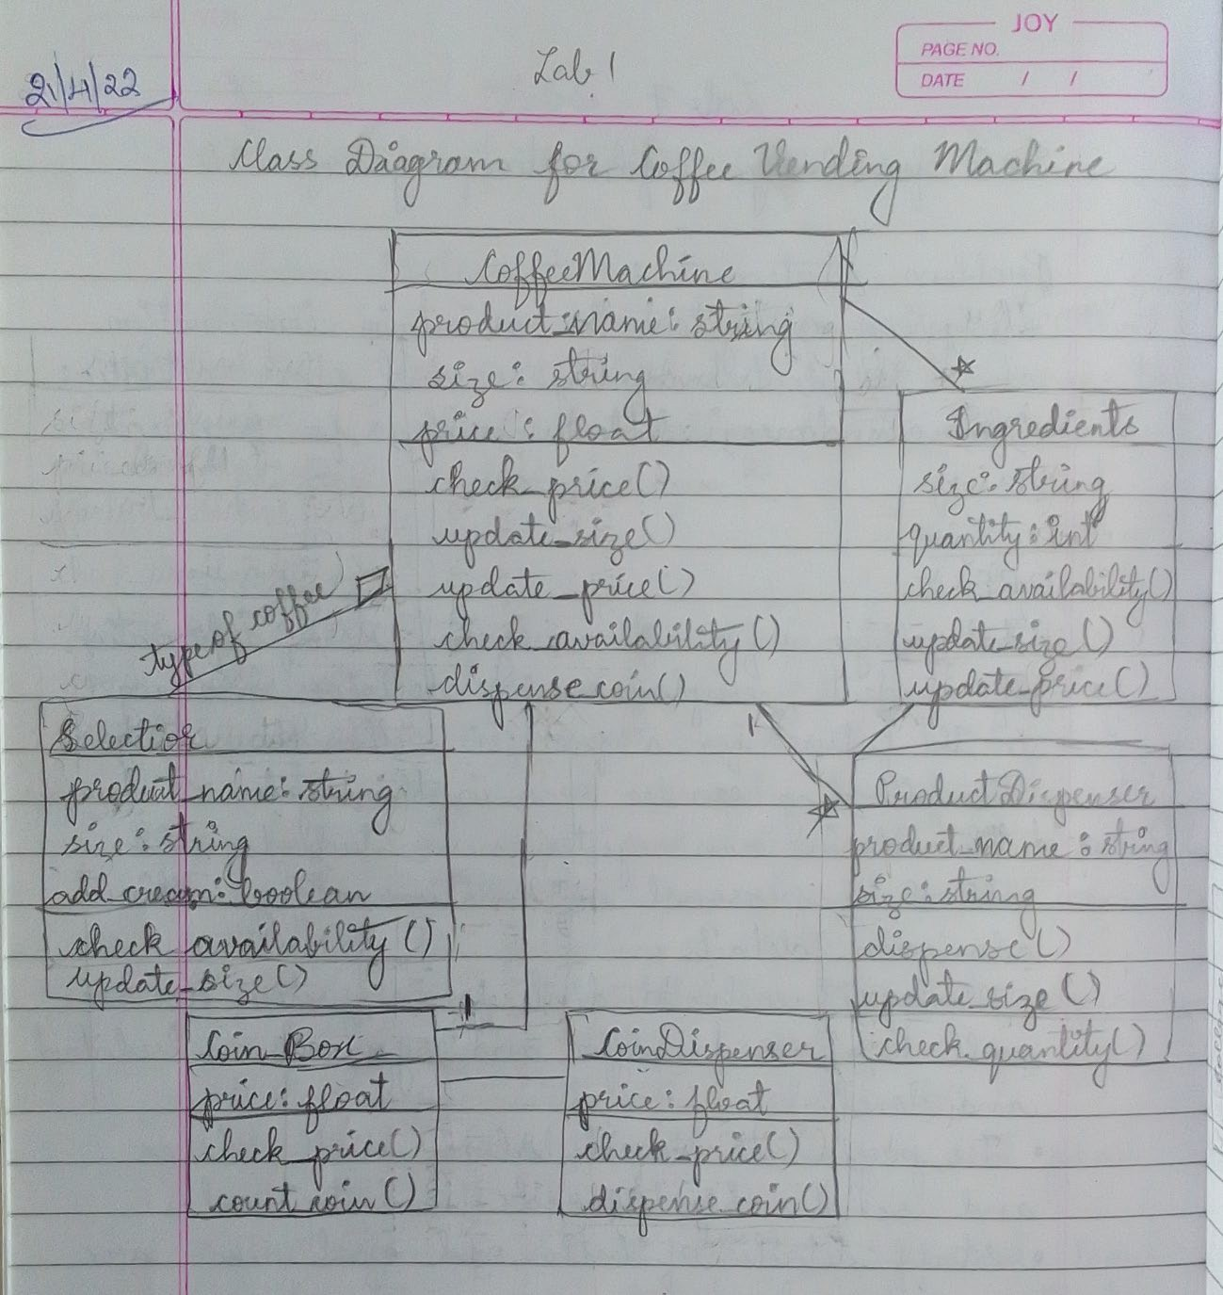

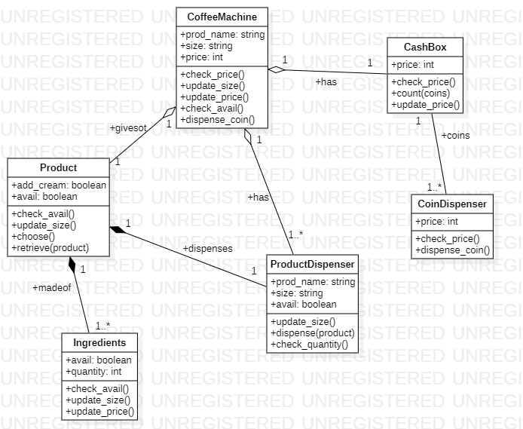

The class diagram as shown above depicts various features of advanced class diagram such as aggregation, composition, etc. The diagram has CoffeeMachine, Product, Ingredients, ProdctDispenser, CashBox and CoinDispenser as its classes.

1. **Advanced State Diagram**

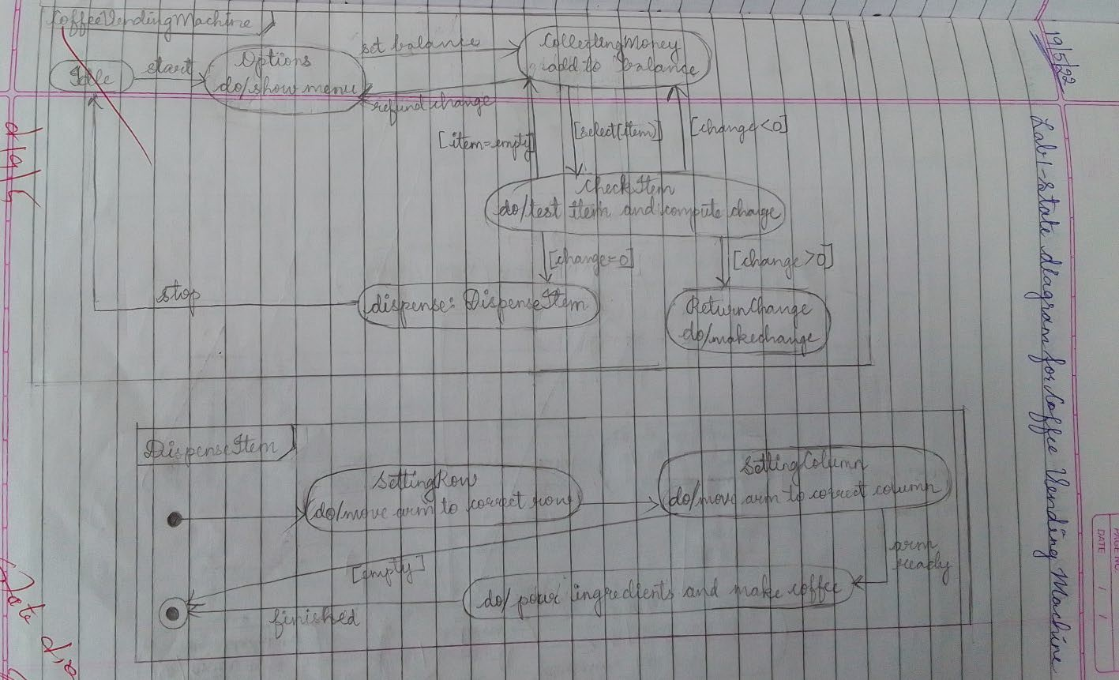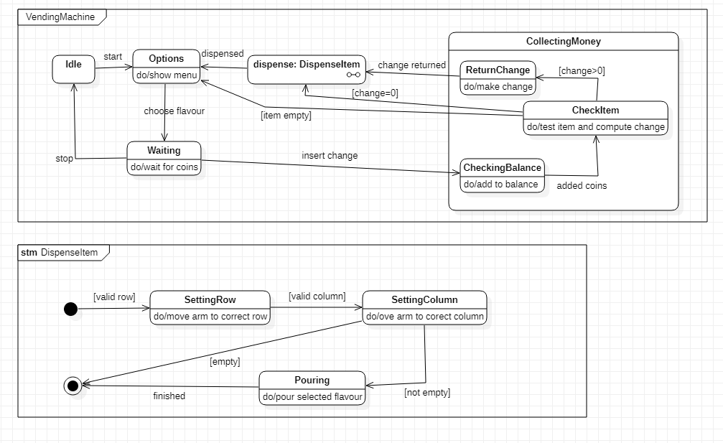

In the above shown advanced activity diagram, the scenario is the customer puts in coin in the machine and selects product. If the amount put in is not sufficient, the customer is indicated to put in more coins, if more amount is inserted, the coin dispenser dispenses coins back. Accordingly, the machine arm will dispense the product to the customer.

1. **Advanced Use case Diagram**

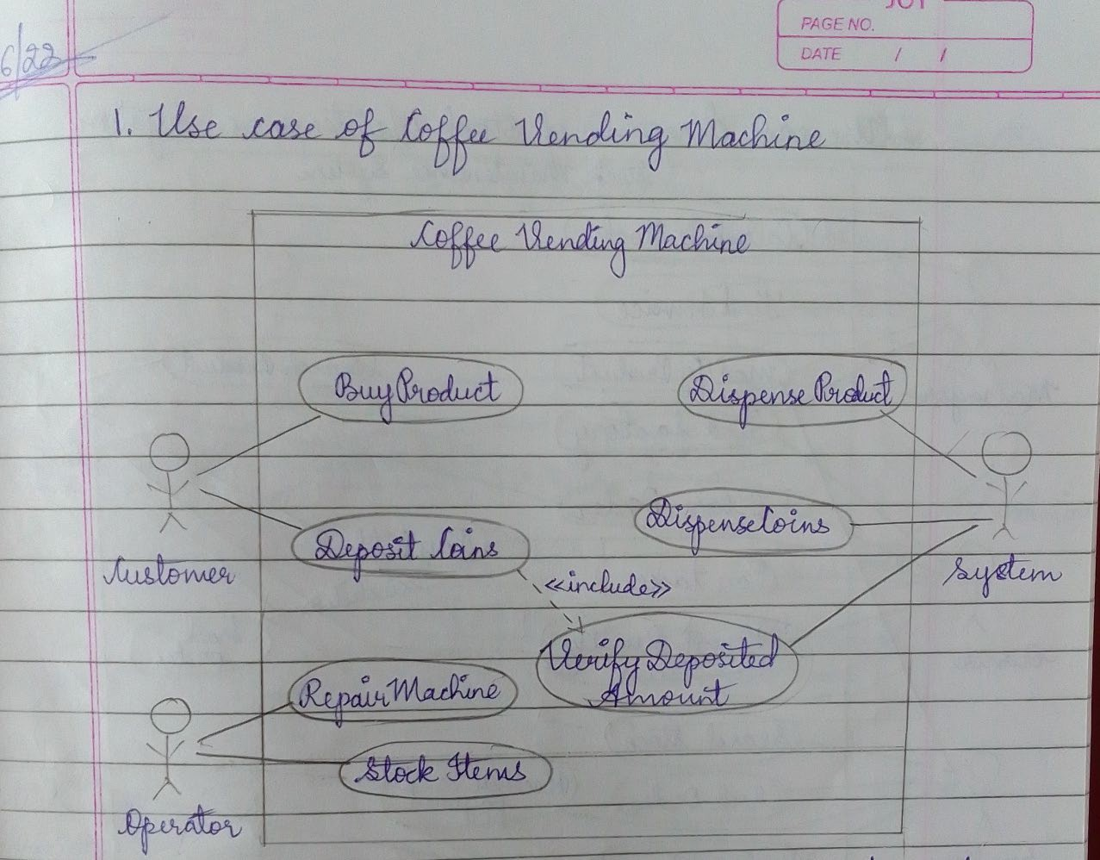

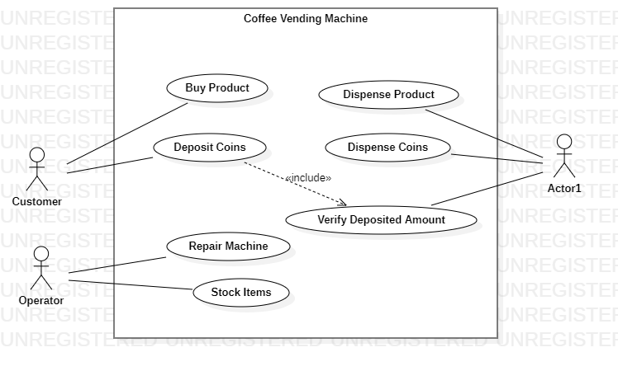

In the above shown use case diagram, advanced include feature is used. Customer, Operator and Machine are the actors and the use cases are shown.

1. **Advanced Sequence Diagram**

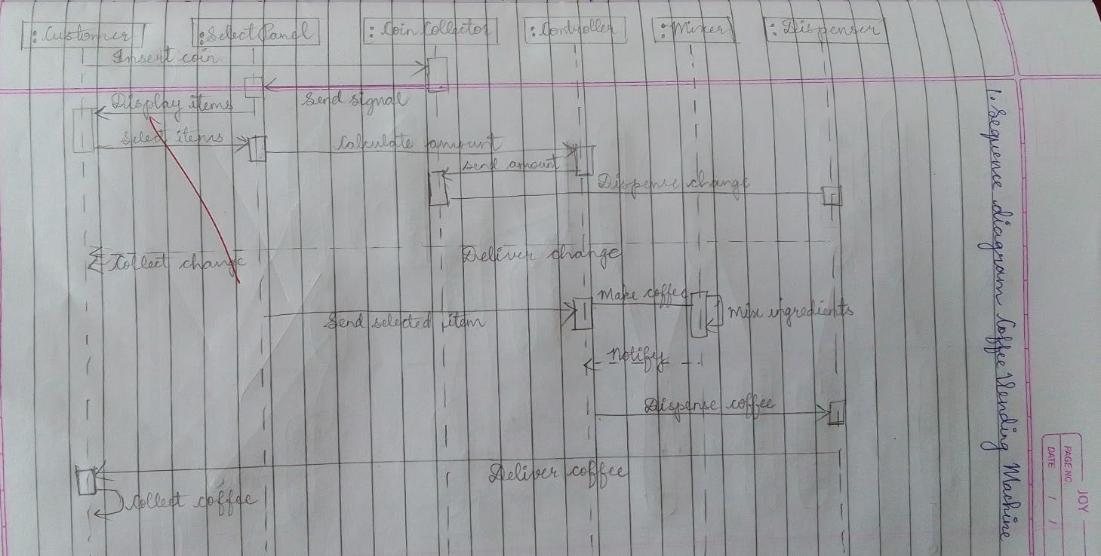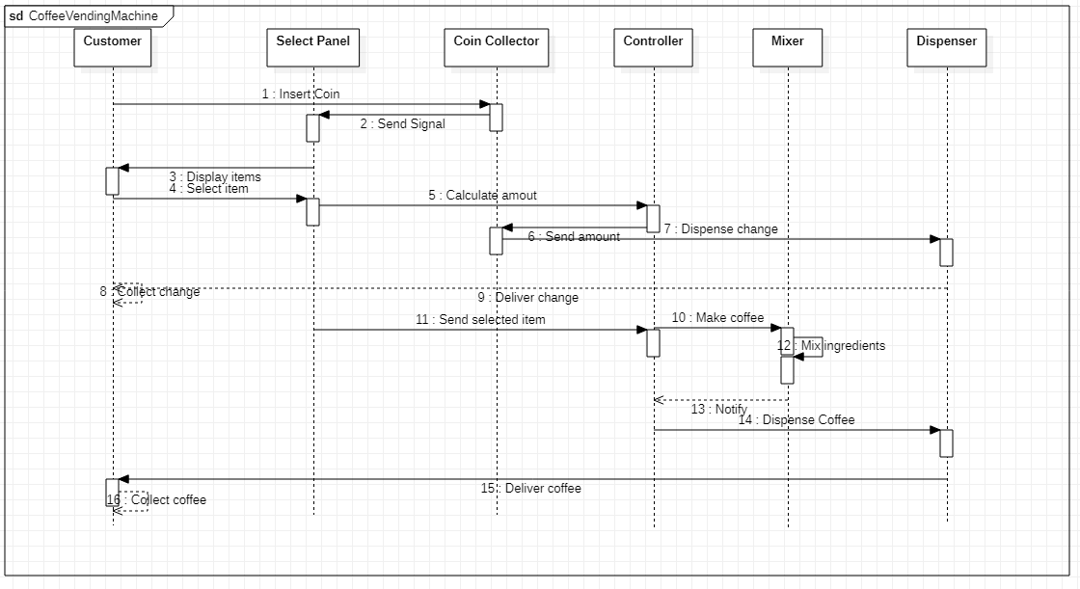

The above sequence diagram shows the sequence of the customer inserting coins and selecting product and the machine doing necessary transactions before dispensing coffee.

1. 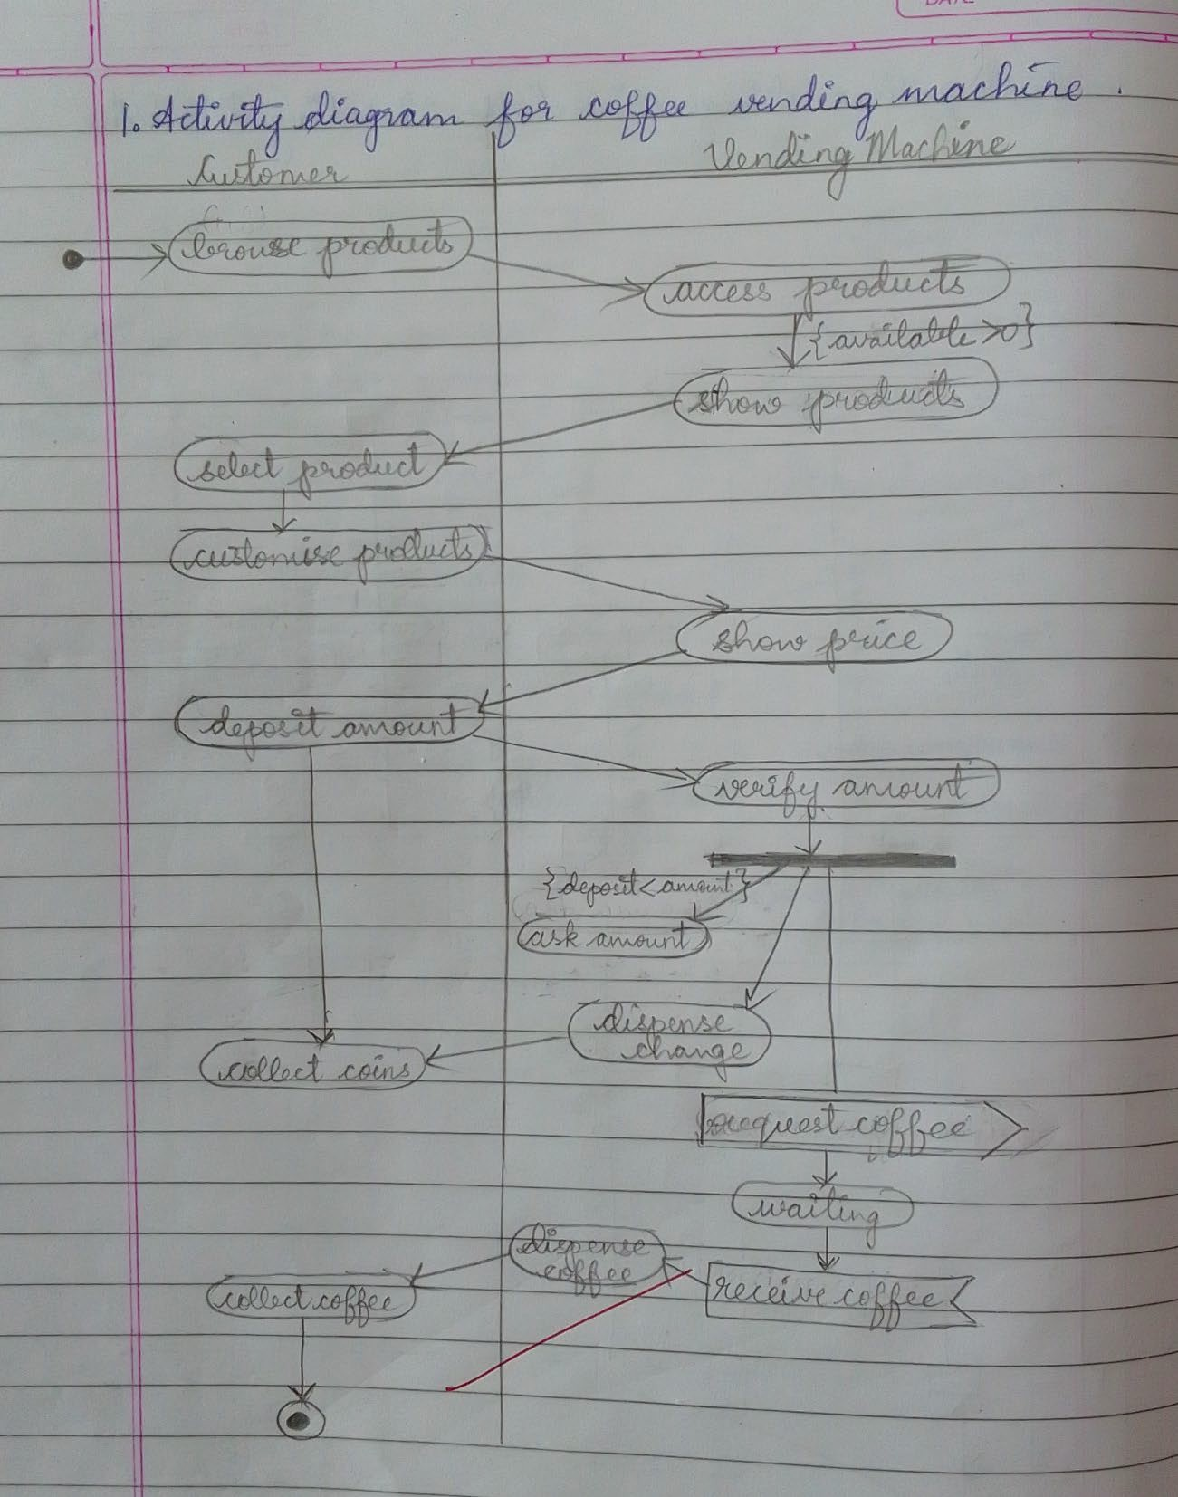**Advanced Activity Diagram**

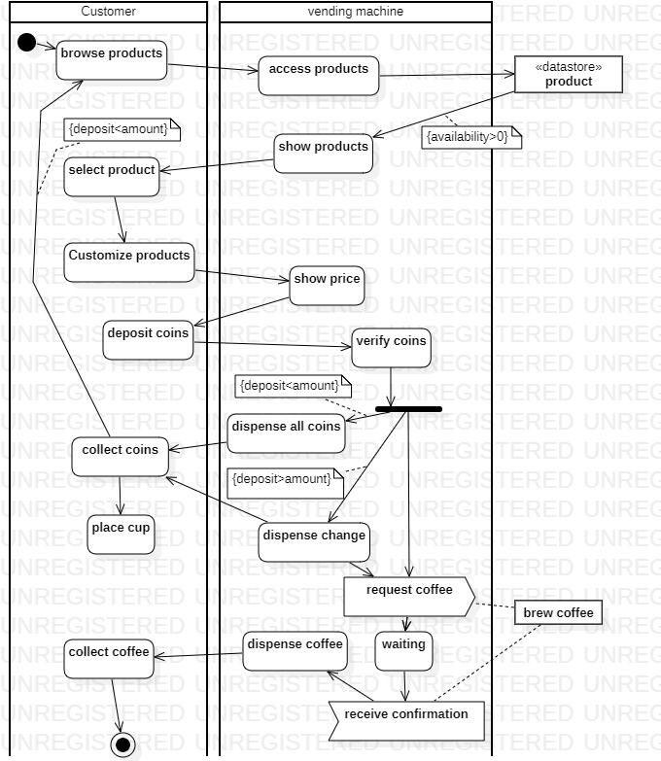

The above activity diagram has advanced features like swimlanes, convex and concave pentagons to show signals. Synchronization fork is also depicted. The start and final states are also shown.

**Exercise 2: Hostel Management System**

# SRS

1. **Advanced Class Diagram**

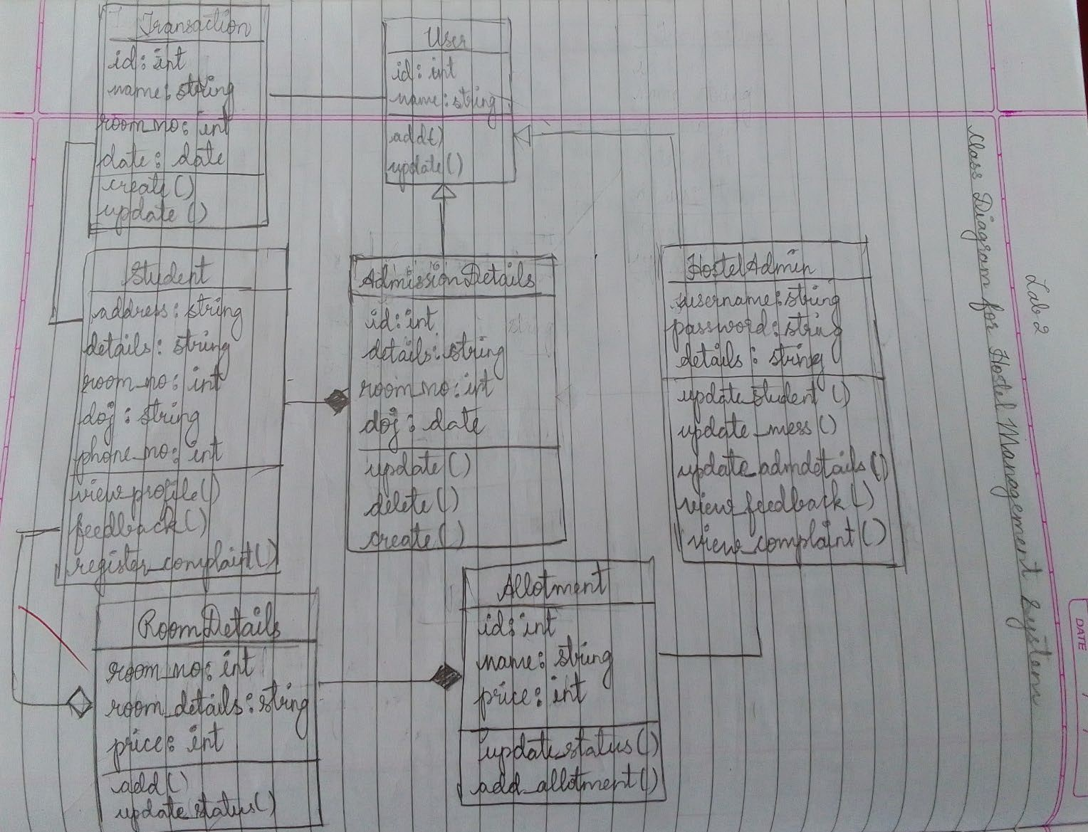

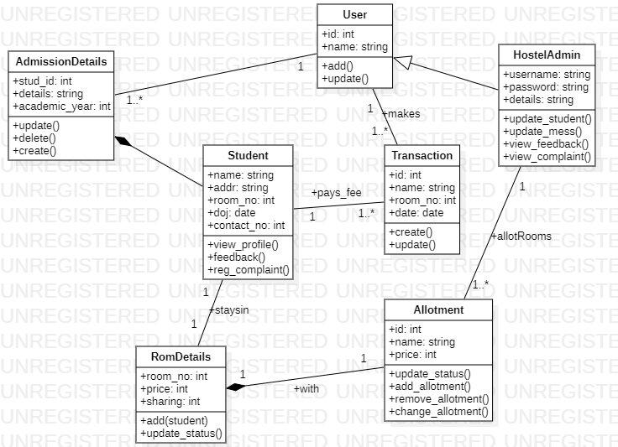

The class diagram has User, AmissionDetails, Studet, Room, Transaction, HostelAdmin and Allotment as its classes. Aggregation and generalization are shown along with multiplicities.

1. **Advanced State Diagram**

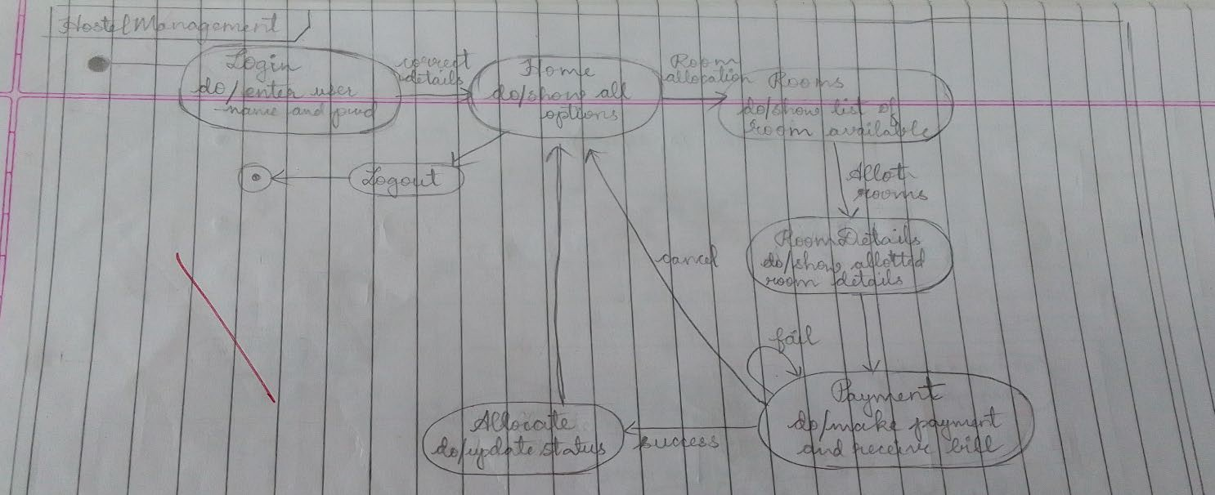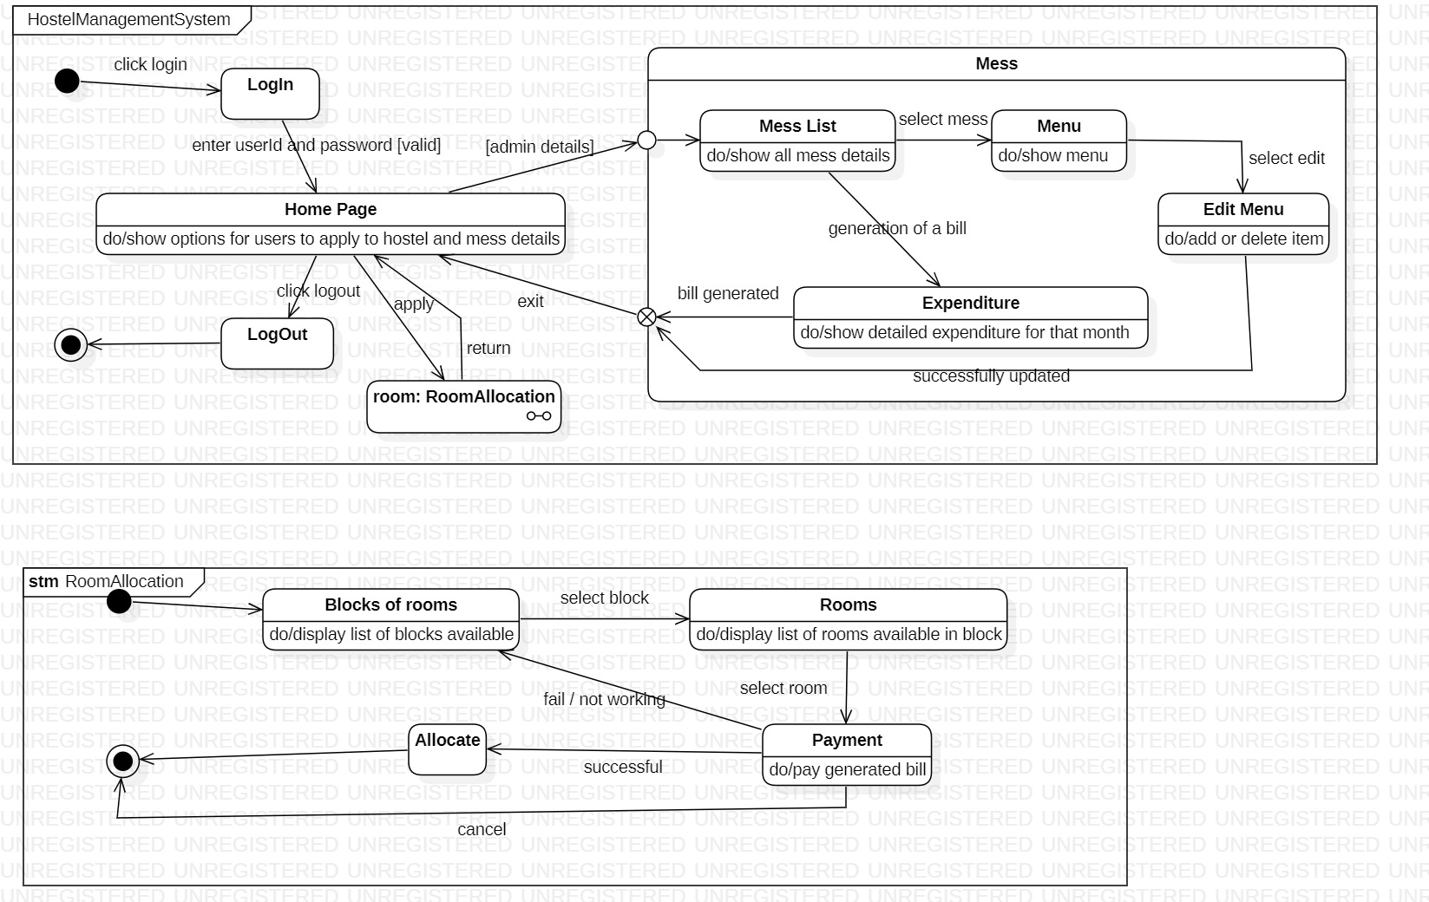

The state diagram depicts the user (student/hostel admin) logging in to the website and viewing rooms, complaints, feedbacks. The substate deals with the availability of rooms, allocation of rooms to students and payment of fees.

1. **Advanced Use case Diagram**

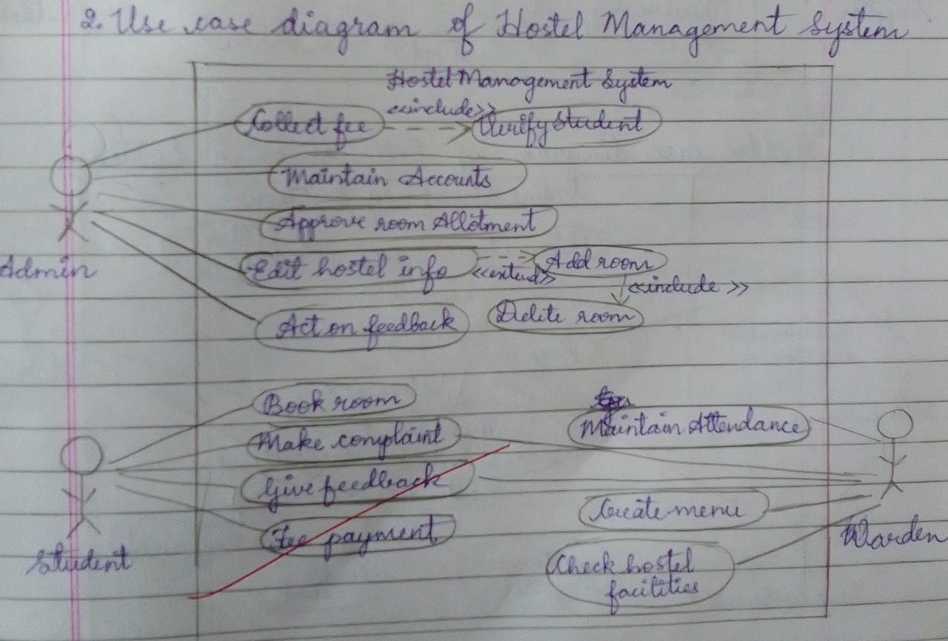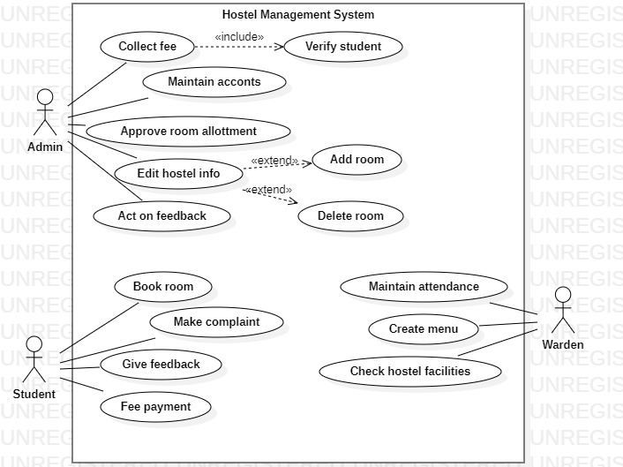

The use case diagram has Student, Warden and Admin as the actors. The actors have use cases as shown above. Student can give feedback and complain, the warden can allot rooms to students. The admin is responsible for updating room details and collection of fee from student.

1. **Advanced Sequence Diagram**

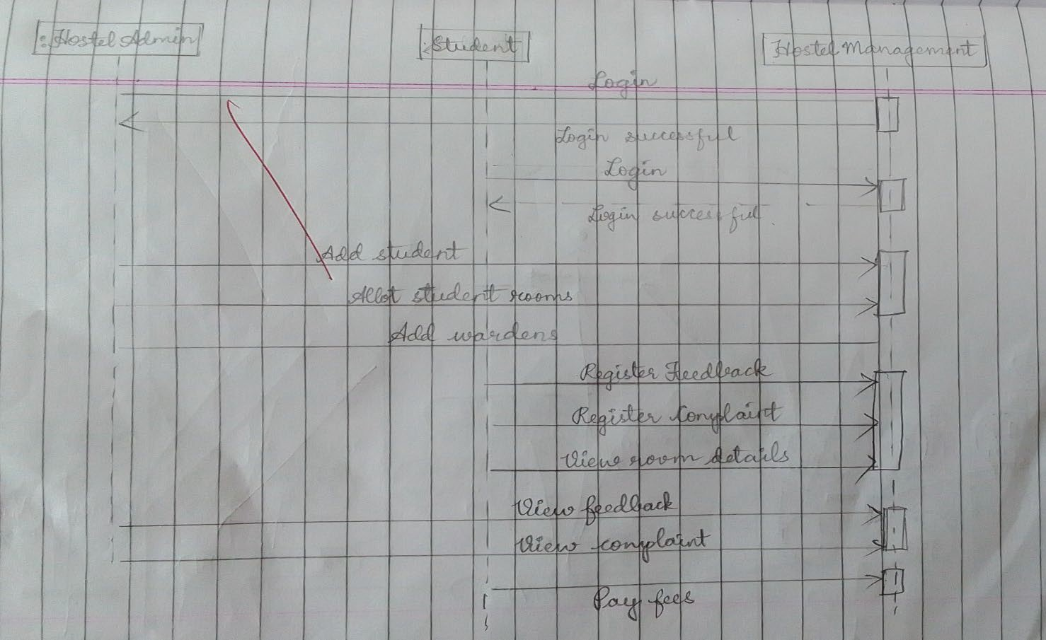

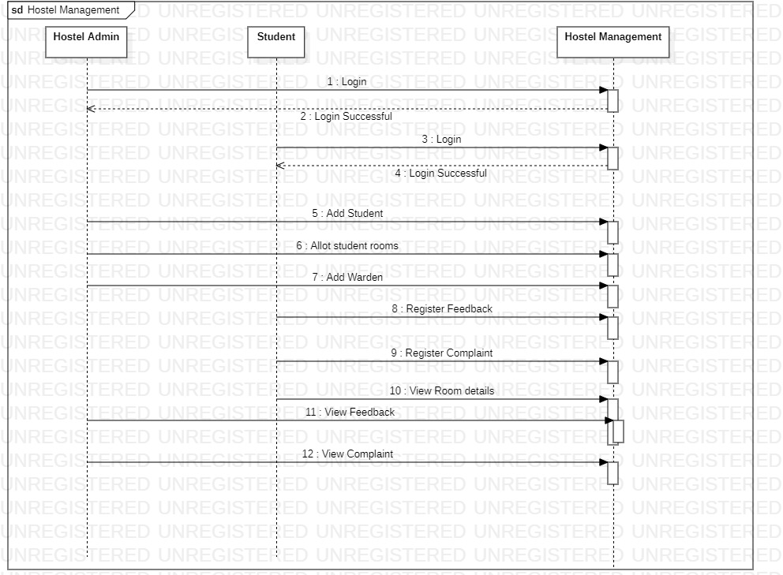

The shown Sequence diagram depicts the sequence of student and admin logging in the website. The admin can add/delete rooms, add/delete warden and review feedback and complaints. The student can pay fees, register feedback and make complains.

1. **Advanced Activity Diagram**

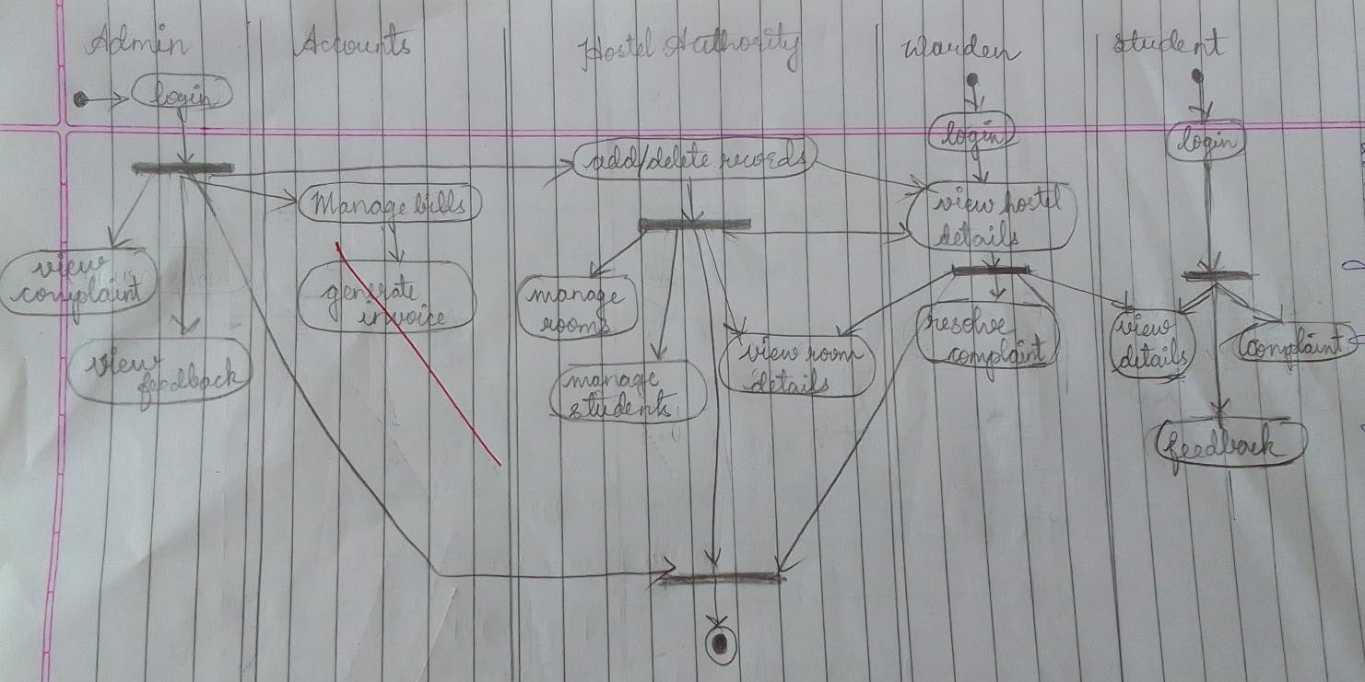

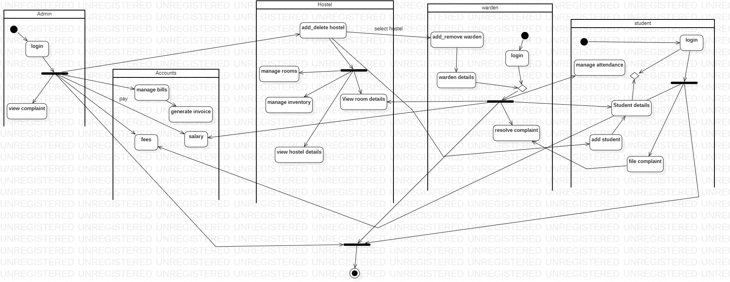

The activity diagram shows the flow of control and activities from the student to warden to payment process.

**Exercise 3: Stock Maintenance System**

# SRS

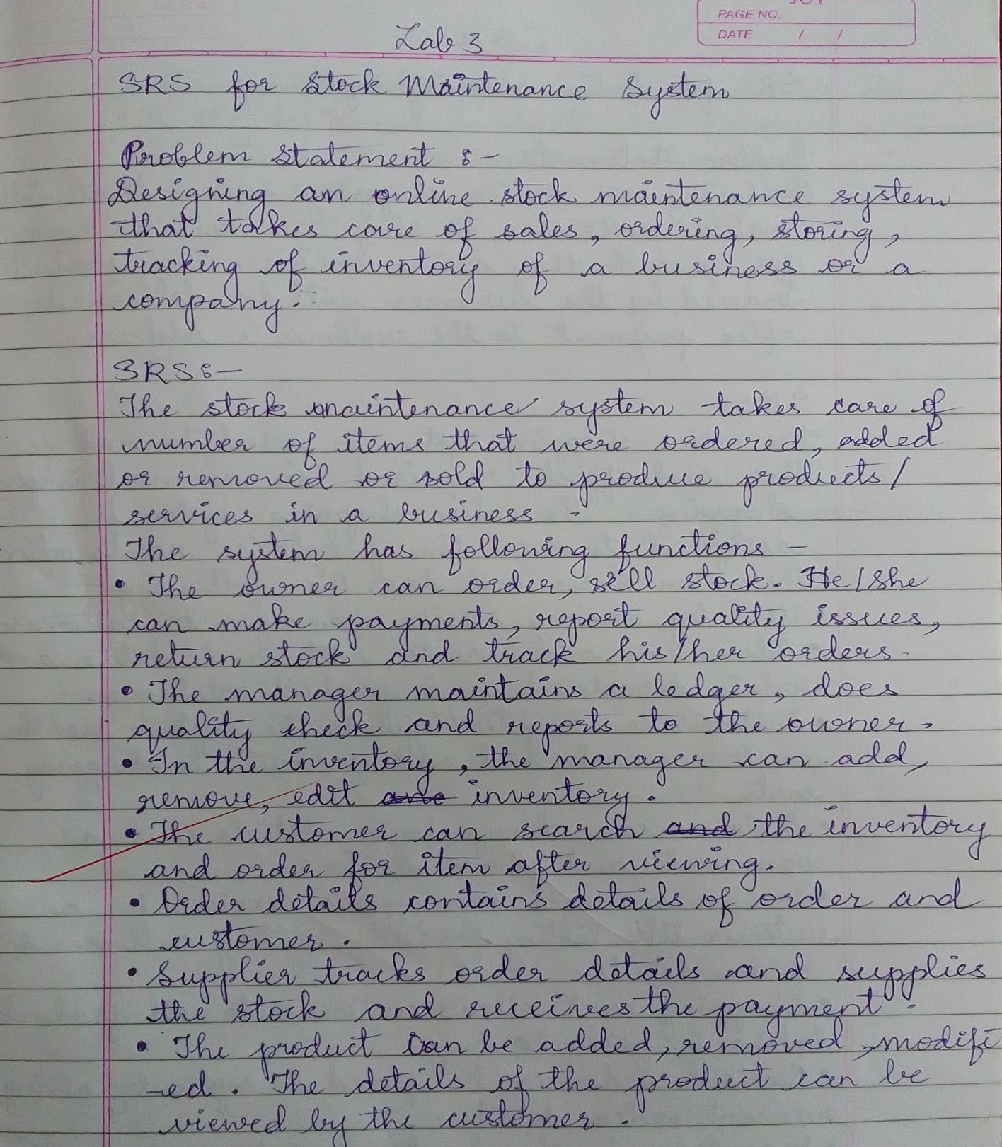

1. **Advanced Class Diagram**

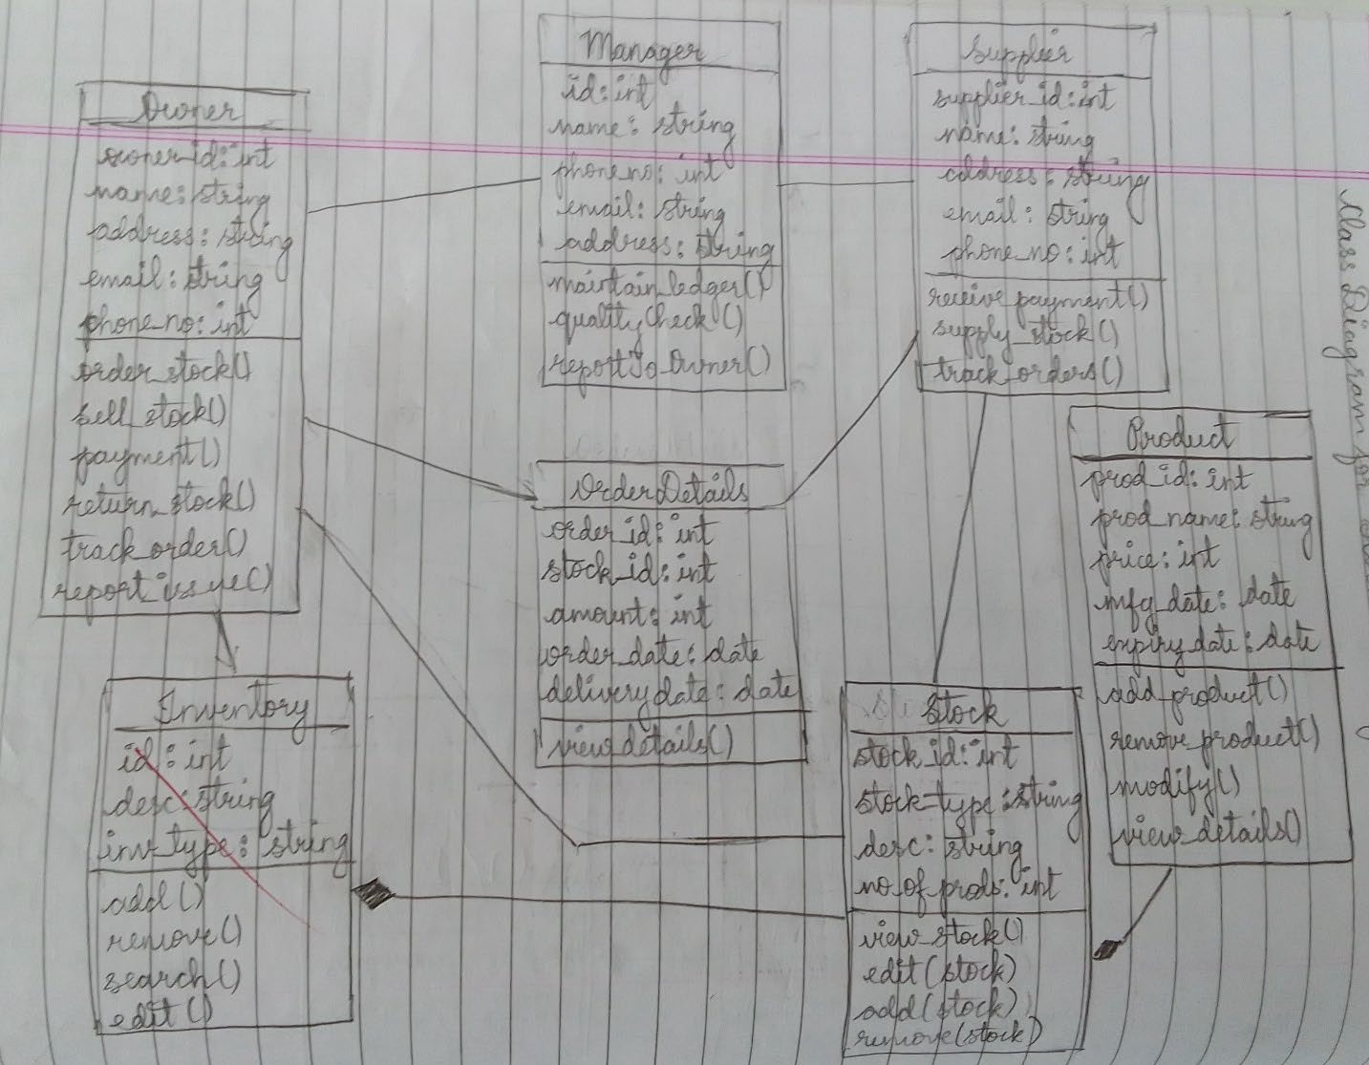

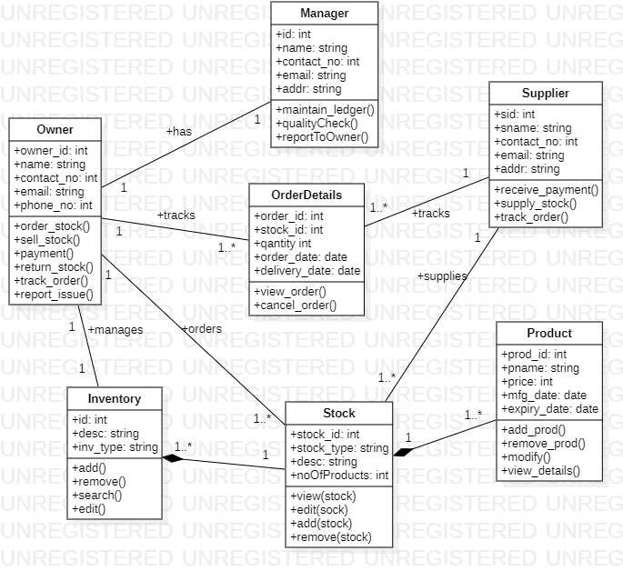

The class diagram has Inventory, Stock, Product, Owner, Supplier and Manager as its classes. The advanced class features such as aggregation and composition are shown along with multiplicity.

1. **Advanced State Diagram**

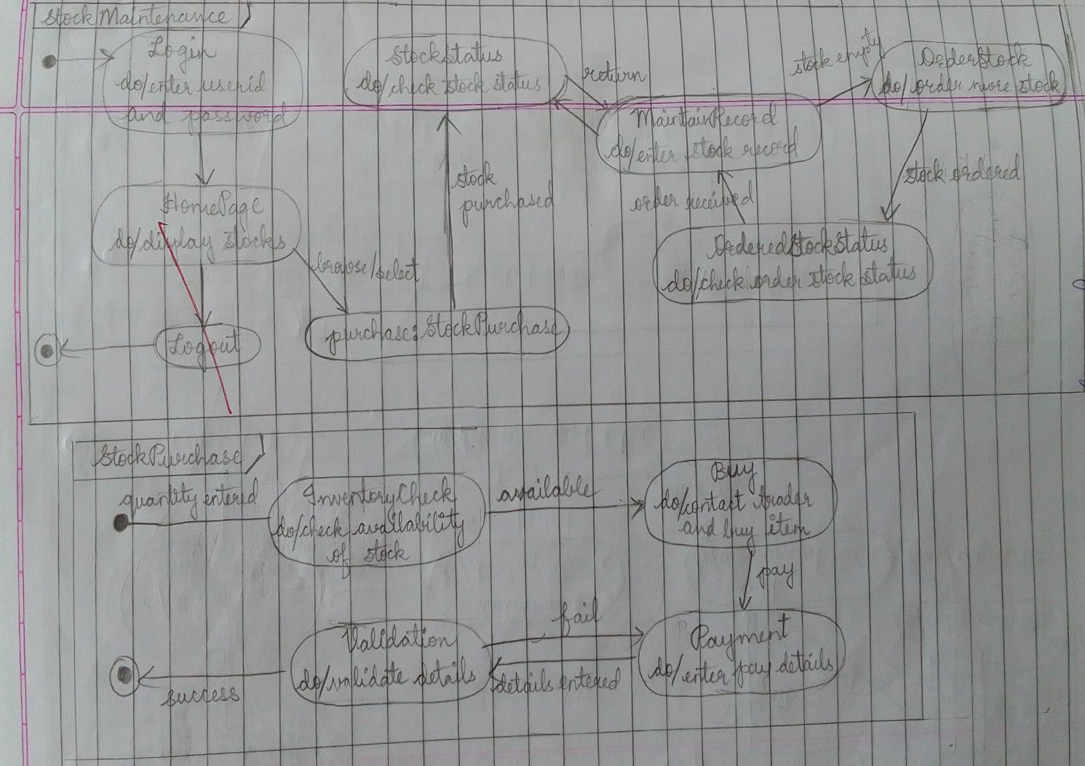

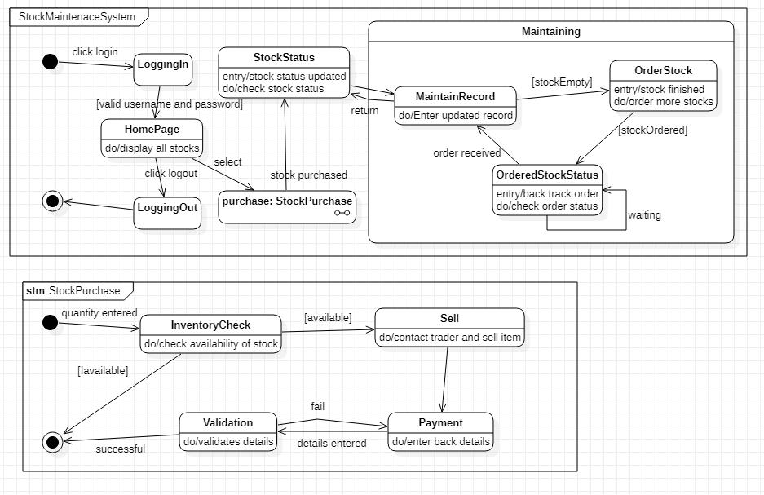

The diagram shows logging into the page, checking stock inventory, selling stocks, maintaining records of stocks along with enabling owner to order stocks, check stock status and sell stocks.

1. **Advanced Use case Diagram**

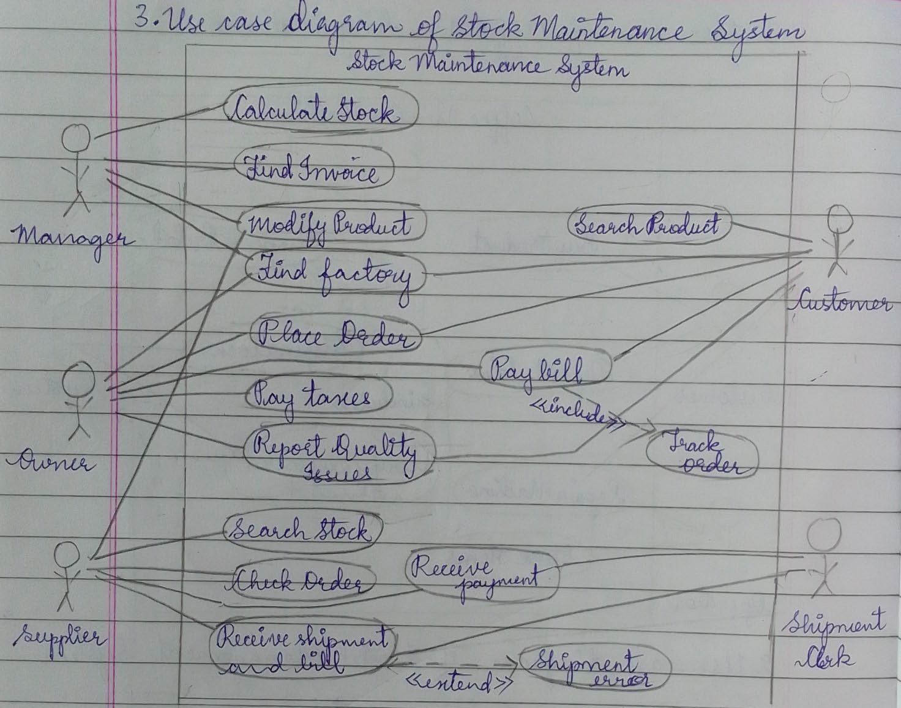

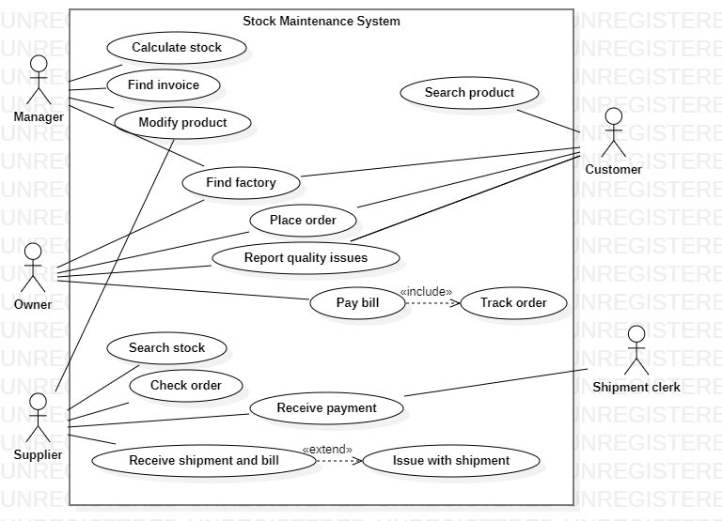

The use case diagram has Owner, Supplier, Customer, Manager as the actors. Each actor is indicated with a use case in the diagram with extend and include advance features.

1. 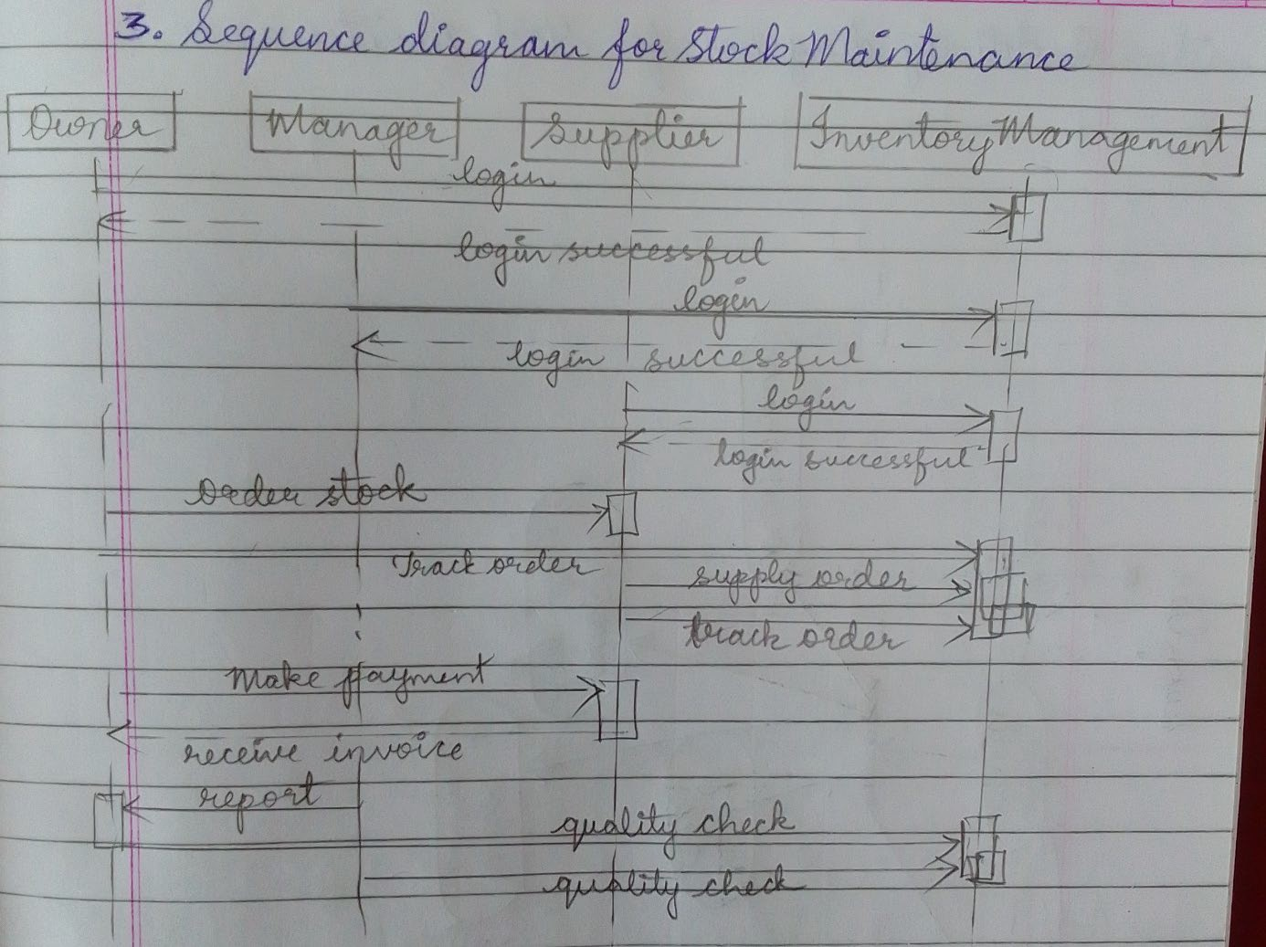**Advanced Sequence Diagram**

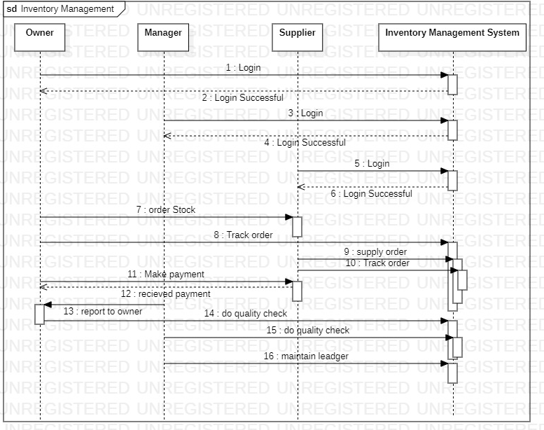

The sequence diagram shows sequence of stock maintenance activities performed by owner, supplier and maintenance of ledger by manager. The owner can order stock from supplier, track order and pay the supplier along with conducting inspection checks.

1. **Advanced Activity Diagram**

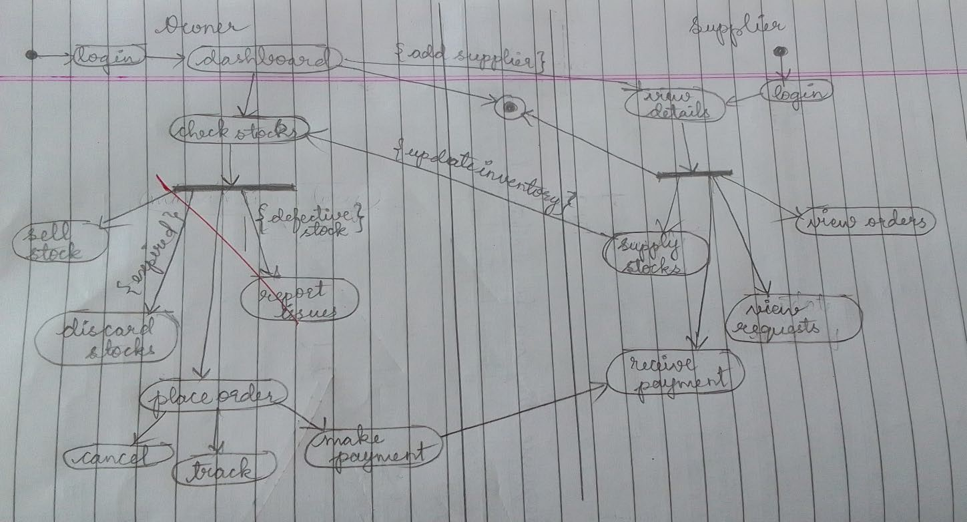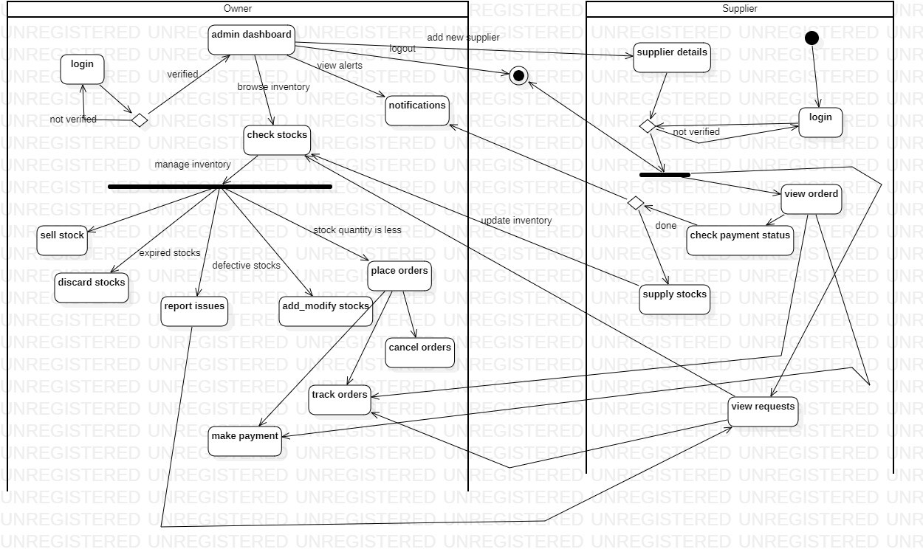

**Exercise 4: Online Shopping System**

# SRS

1. **Advanced Class Diagram**

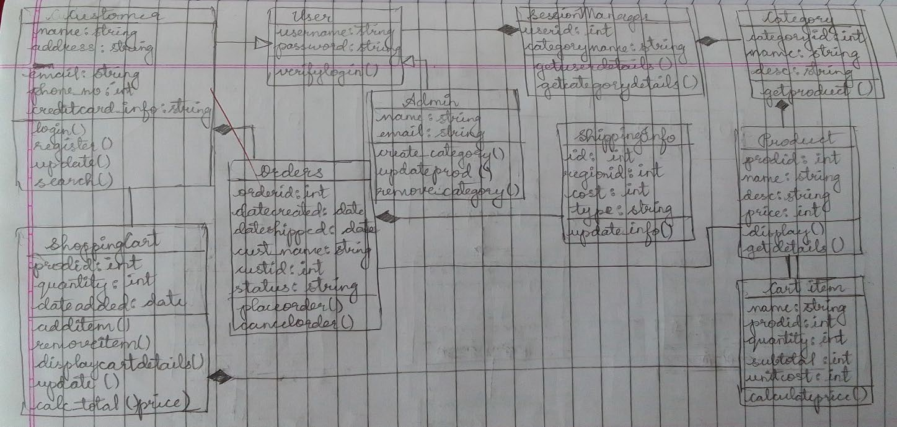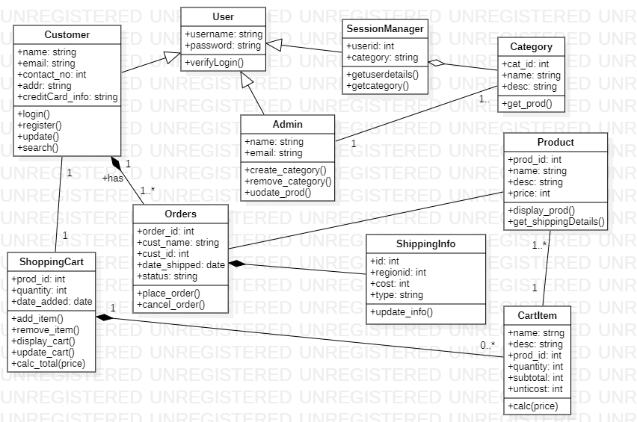

1. **Advanced State Diagram**

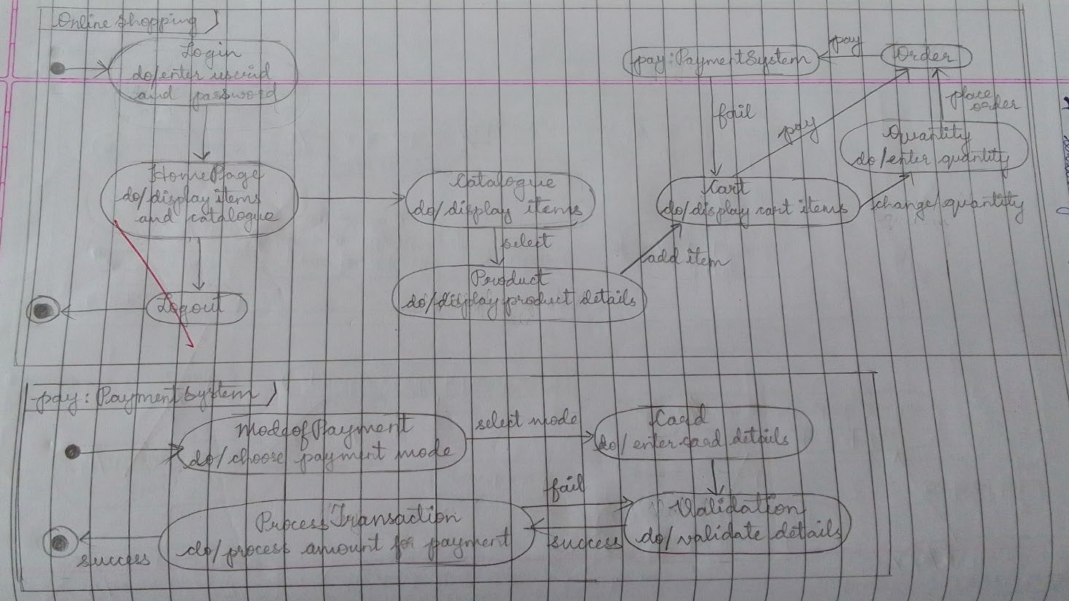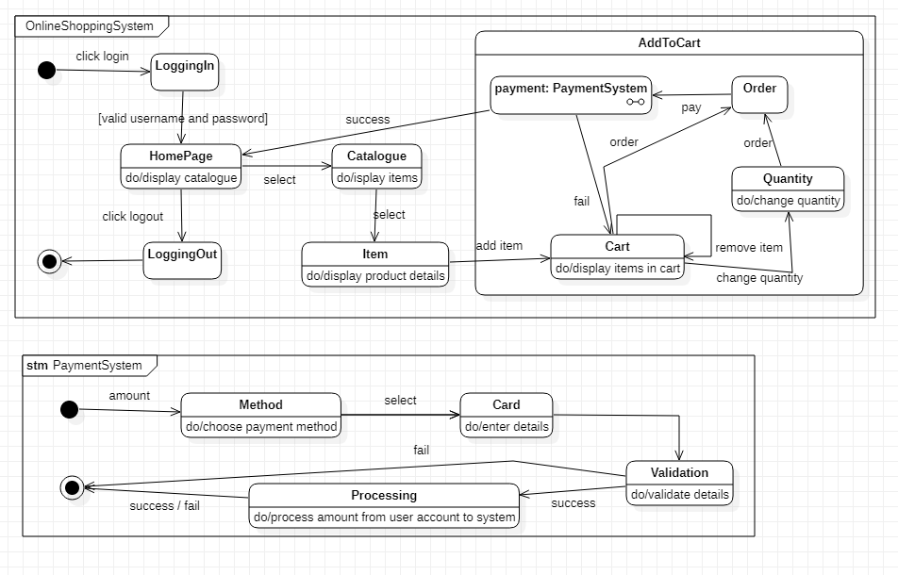

1. **Advanced Use case Diagram**

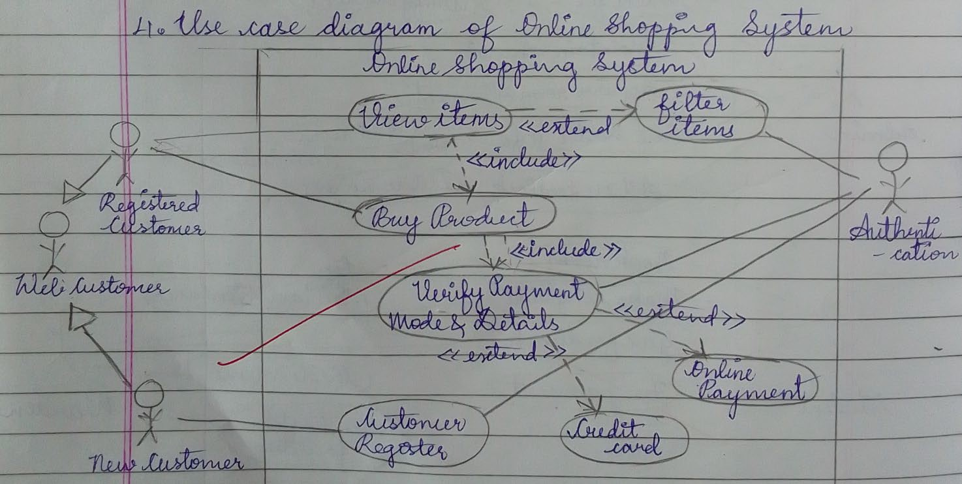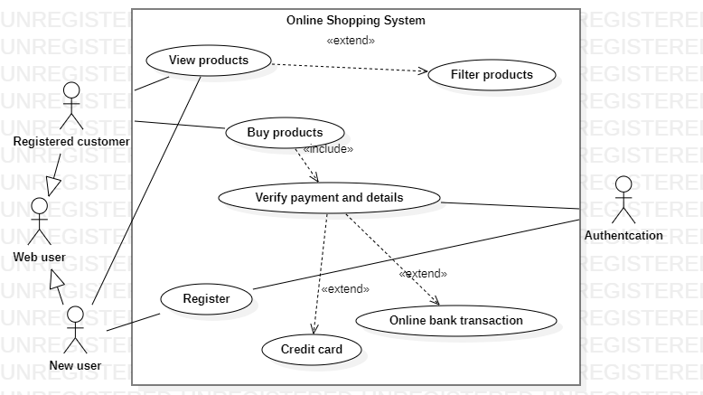

1. **Advanced Sequence Diagram**

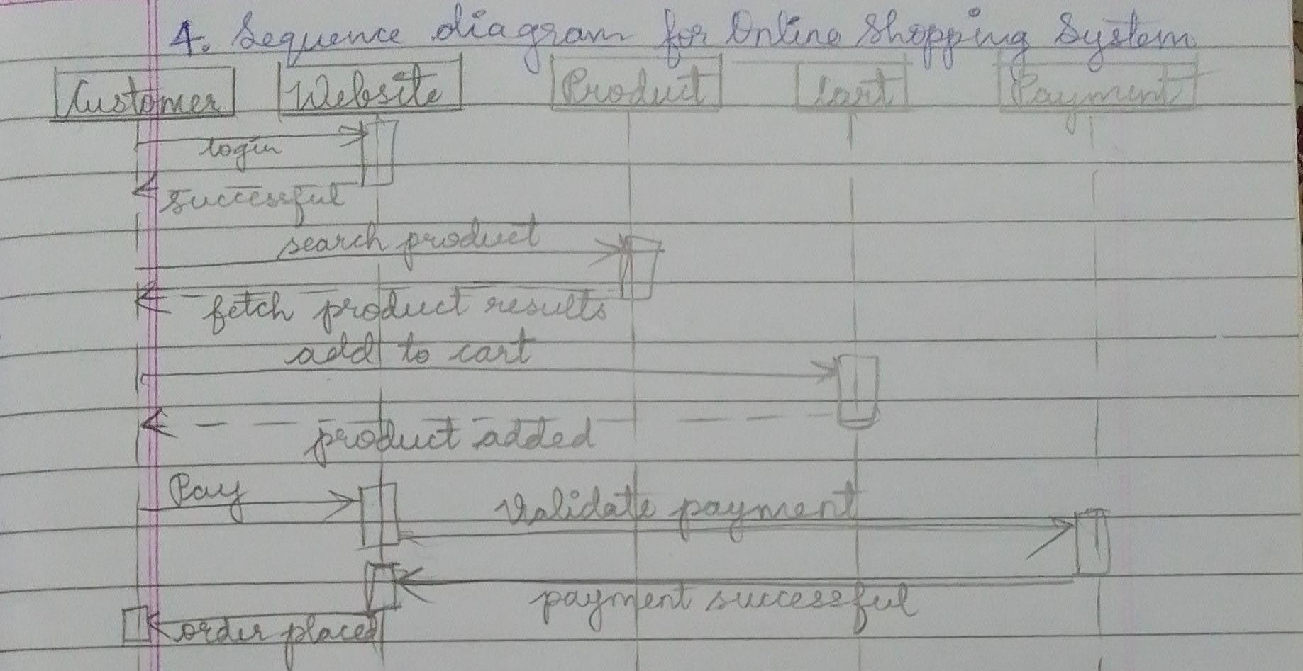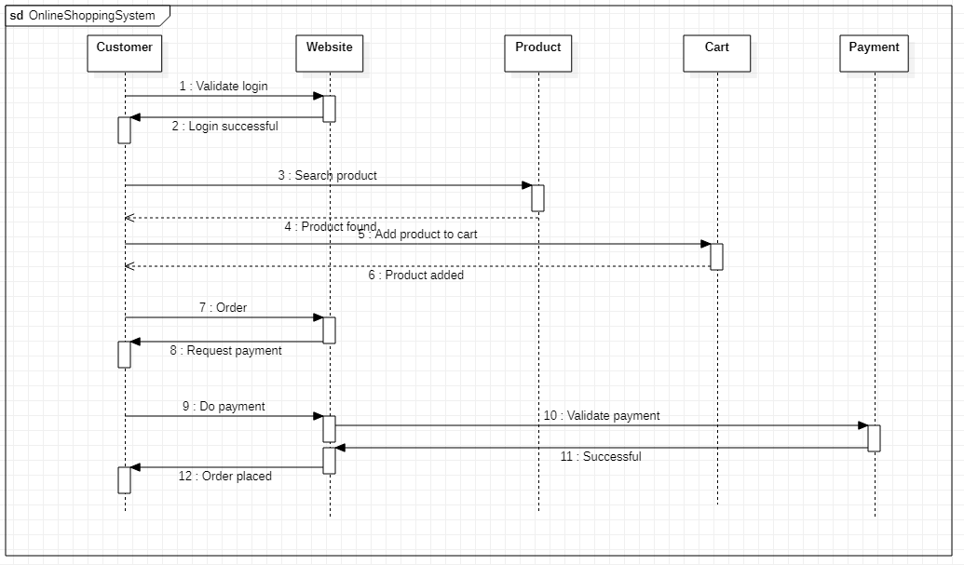

1. **Advanced Activity Diagram**

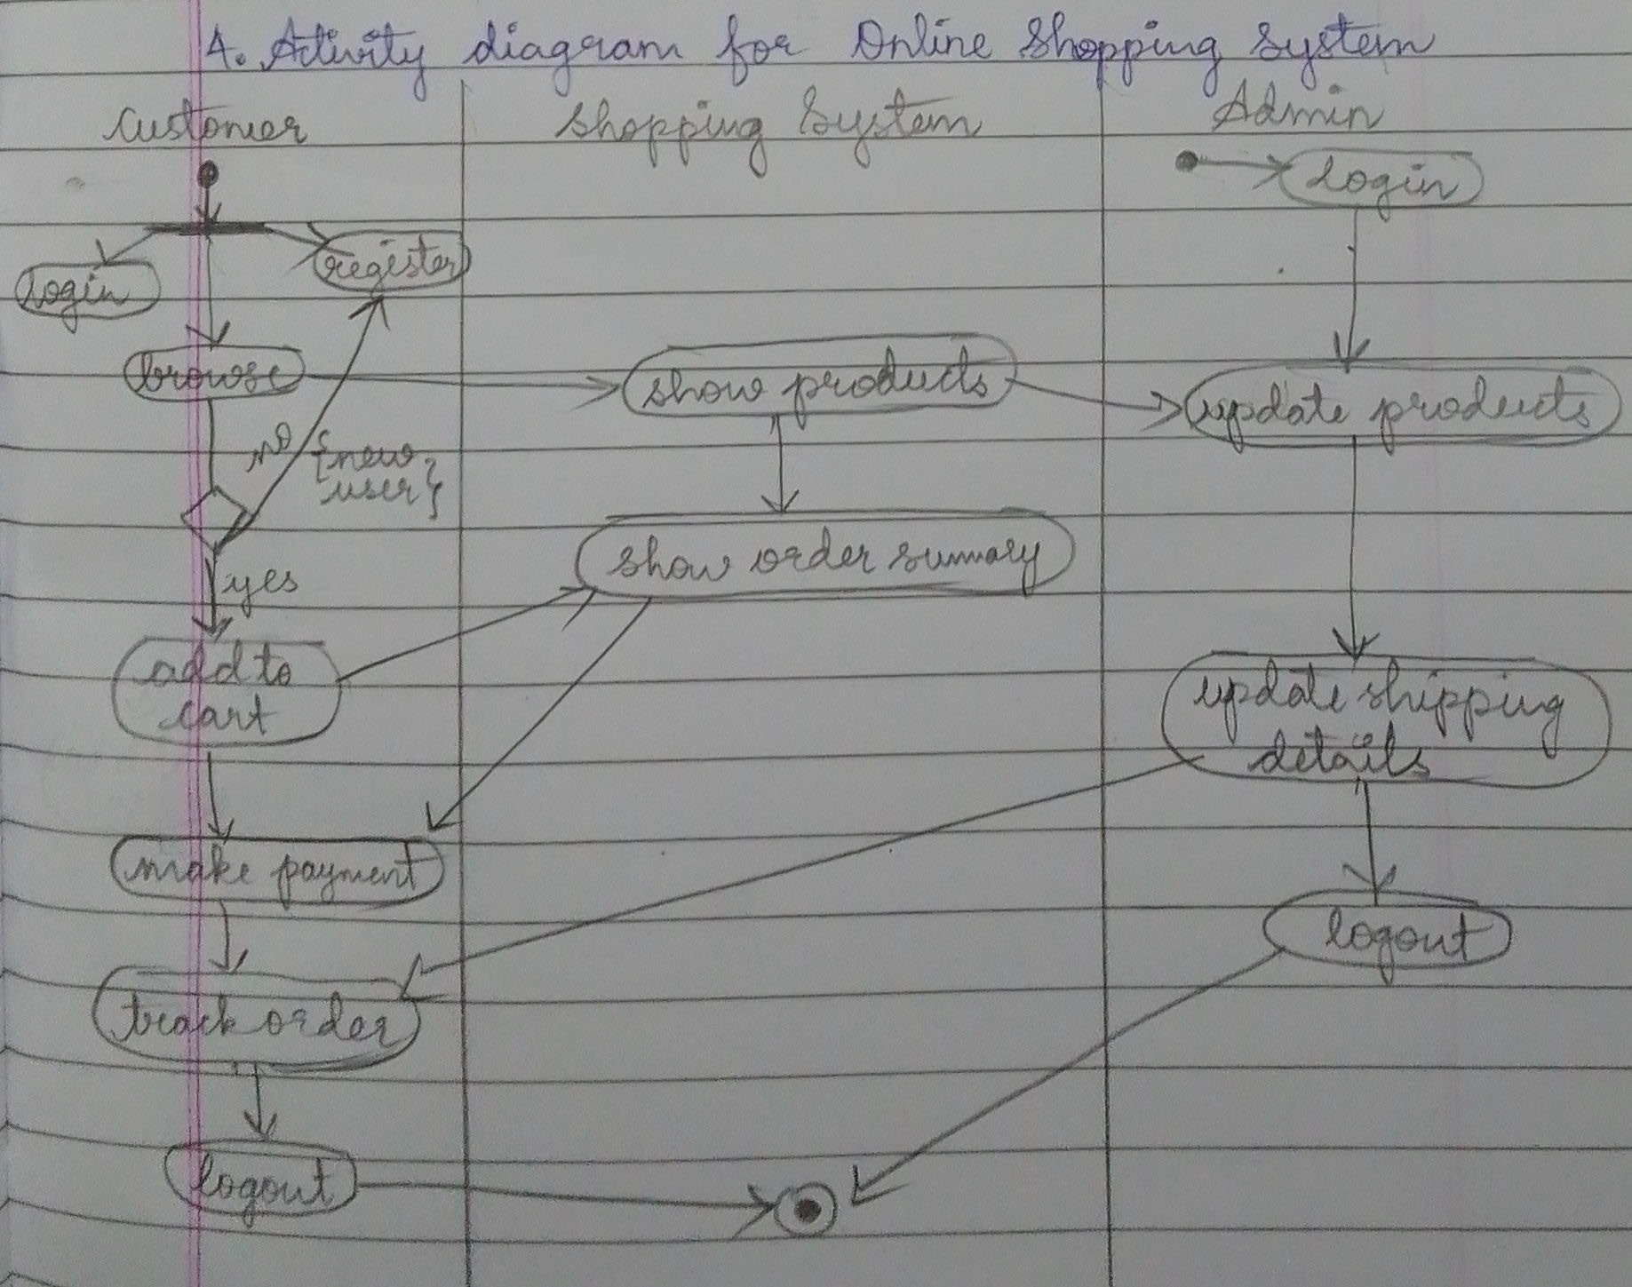

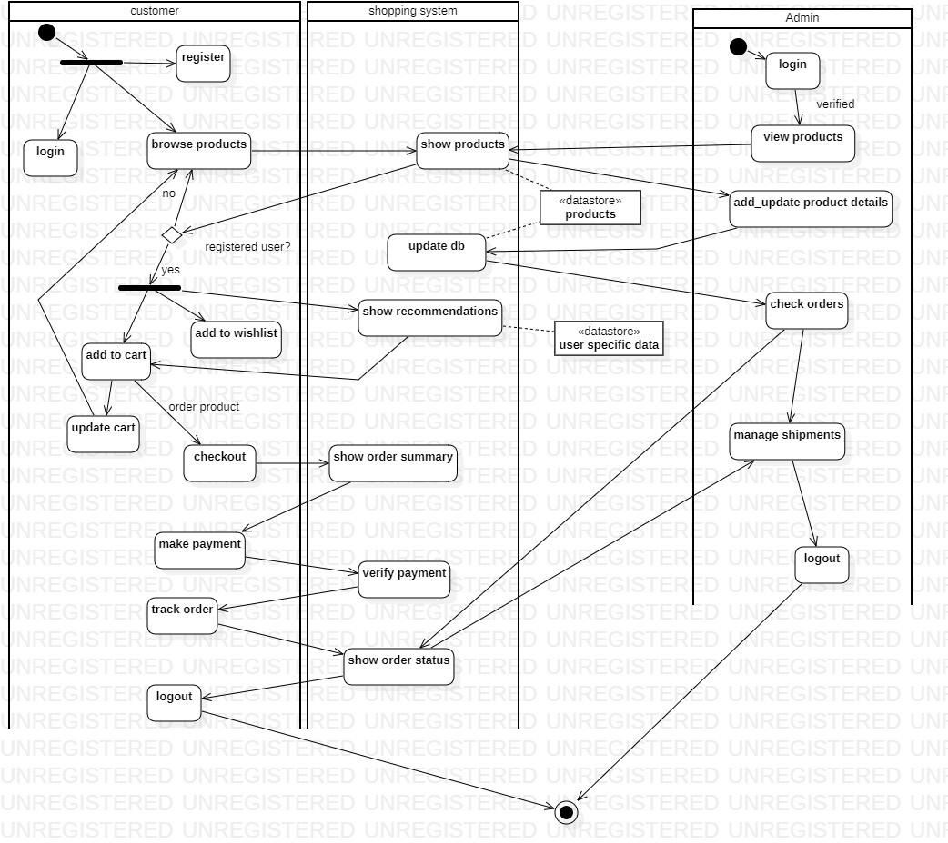

**Exercise 5: Railway Reservation System**

# SRS

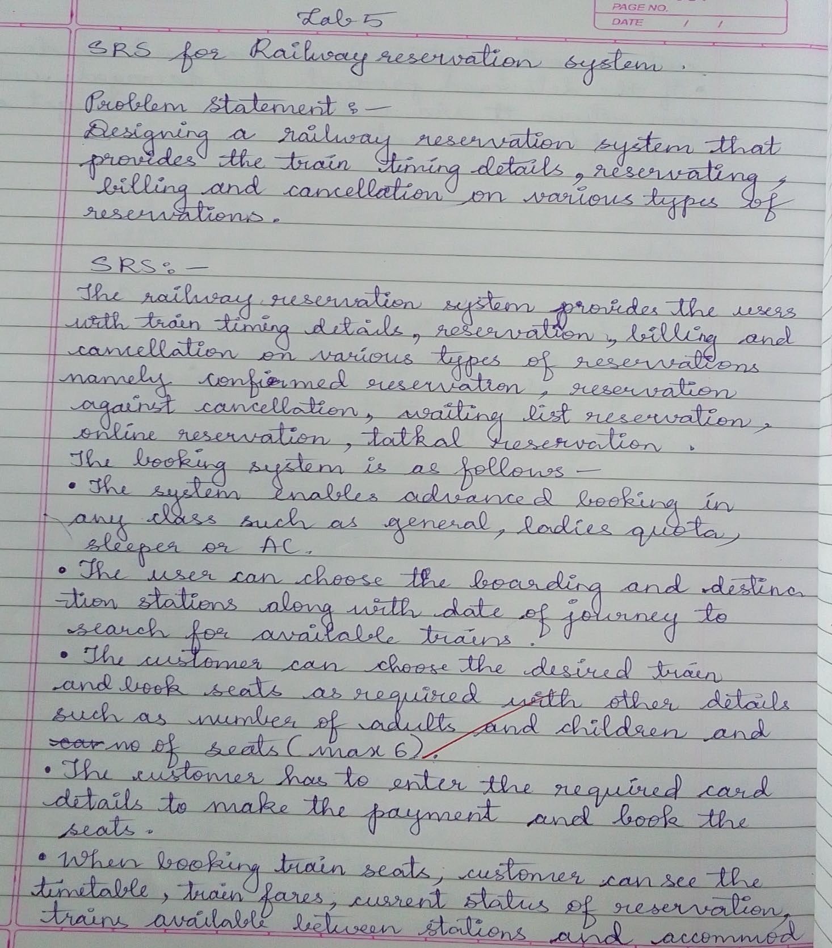

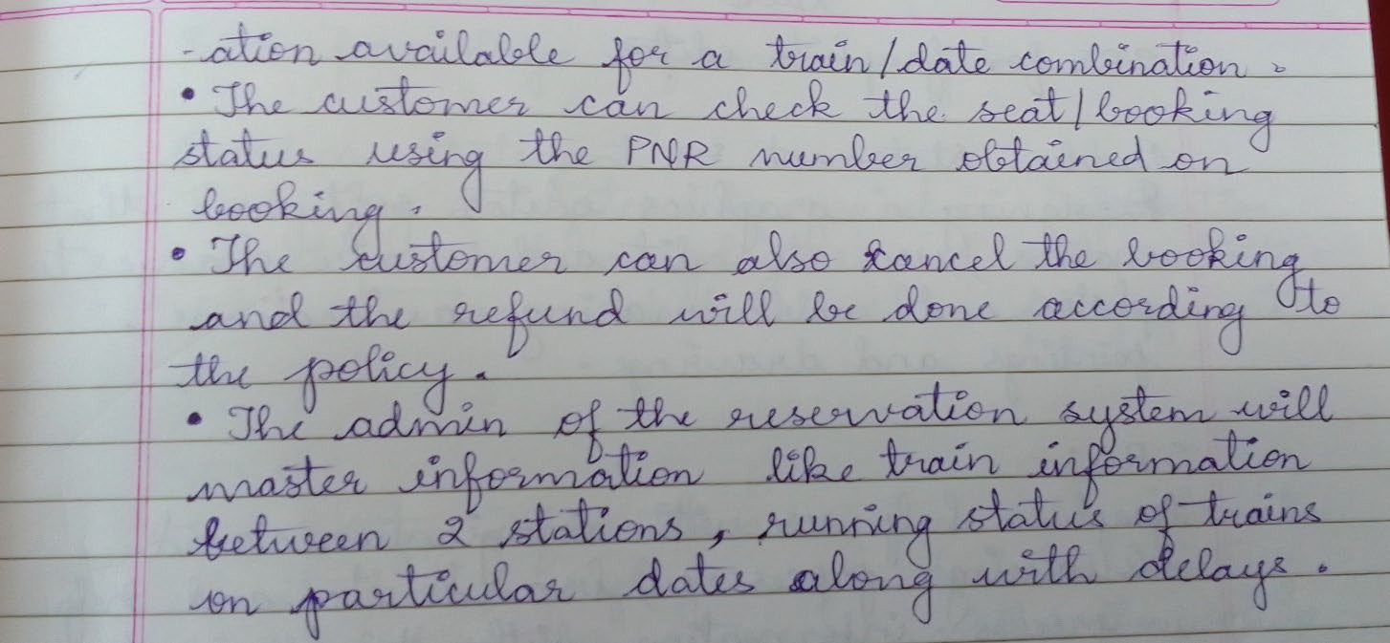

1. **Advanced Class Diagram**

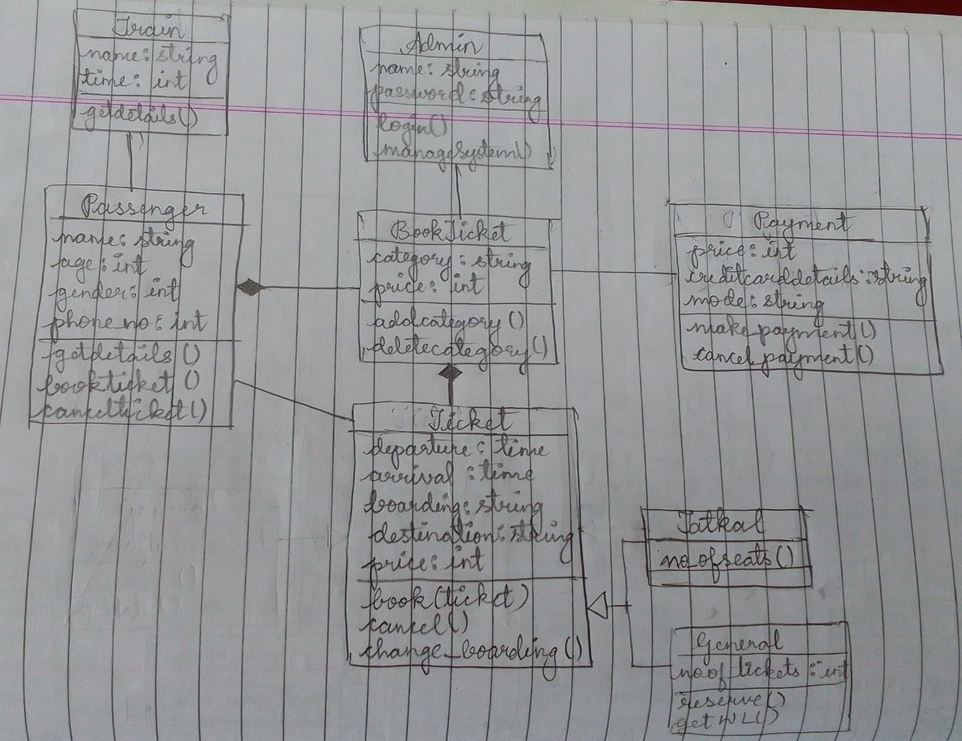

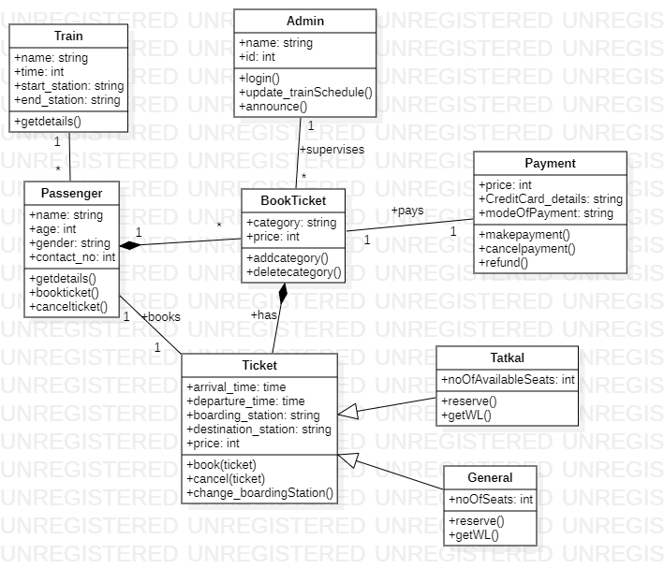

1. **Advanced State Diagram**

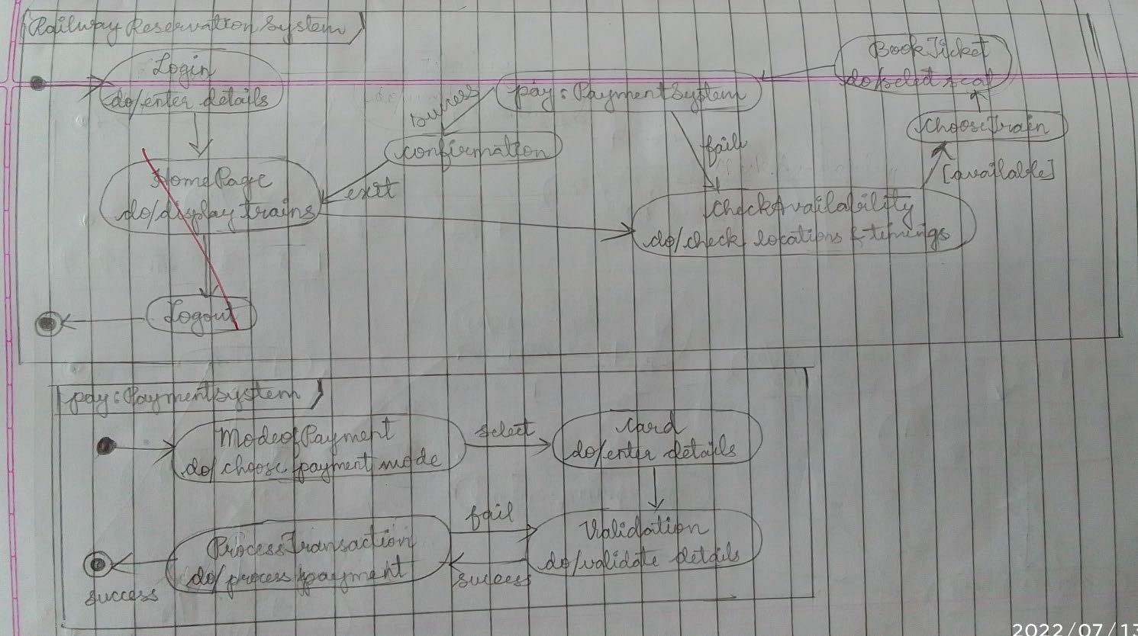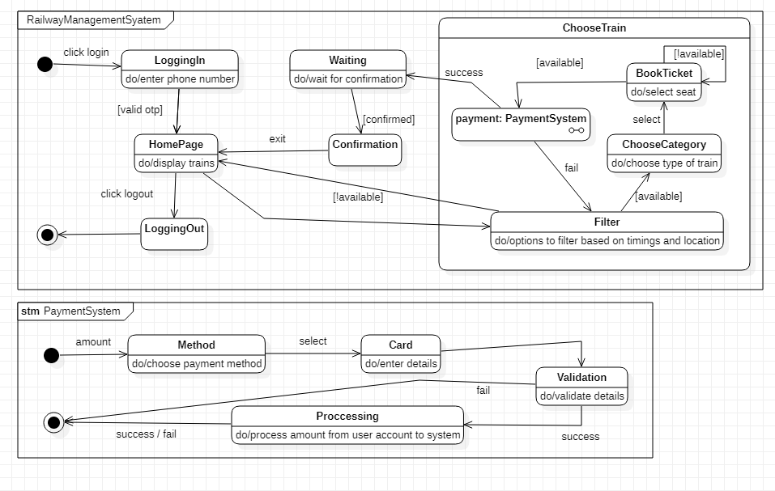

1. **Advanced Use case Diagram**

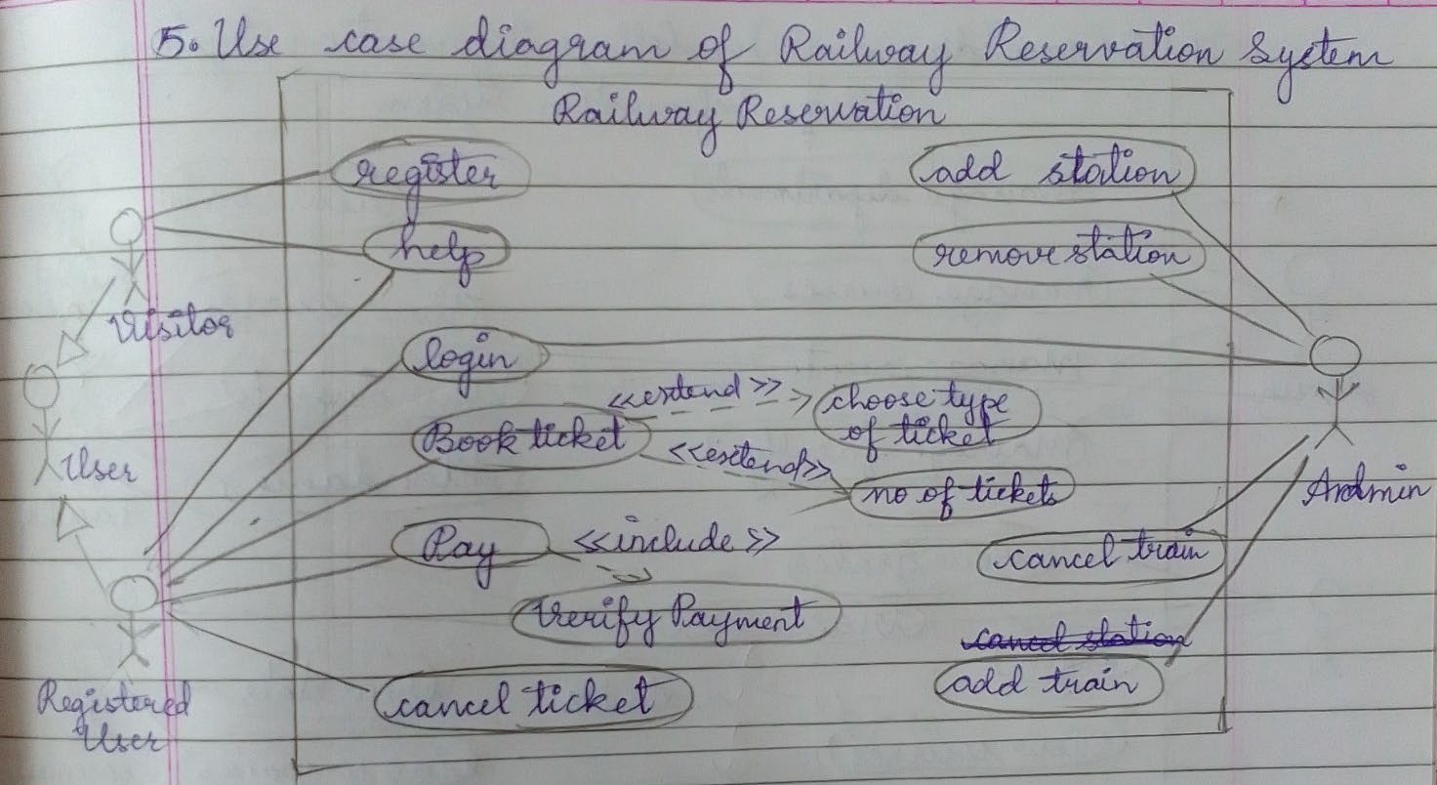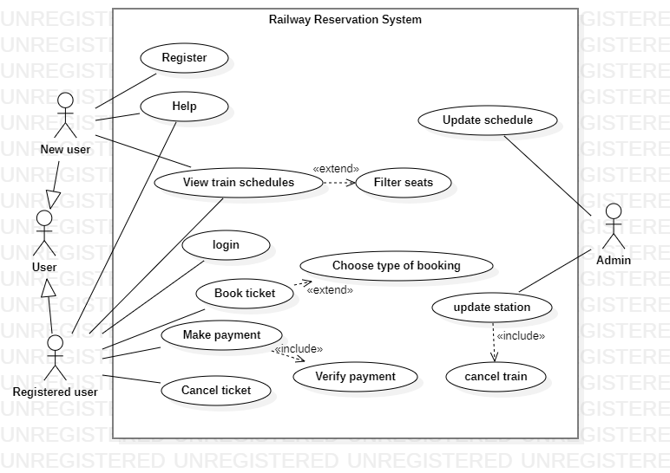

1. **Advanced Sequence Diagram**

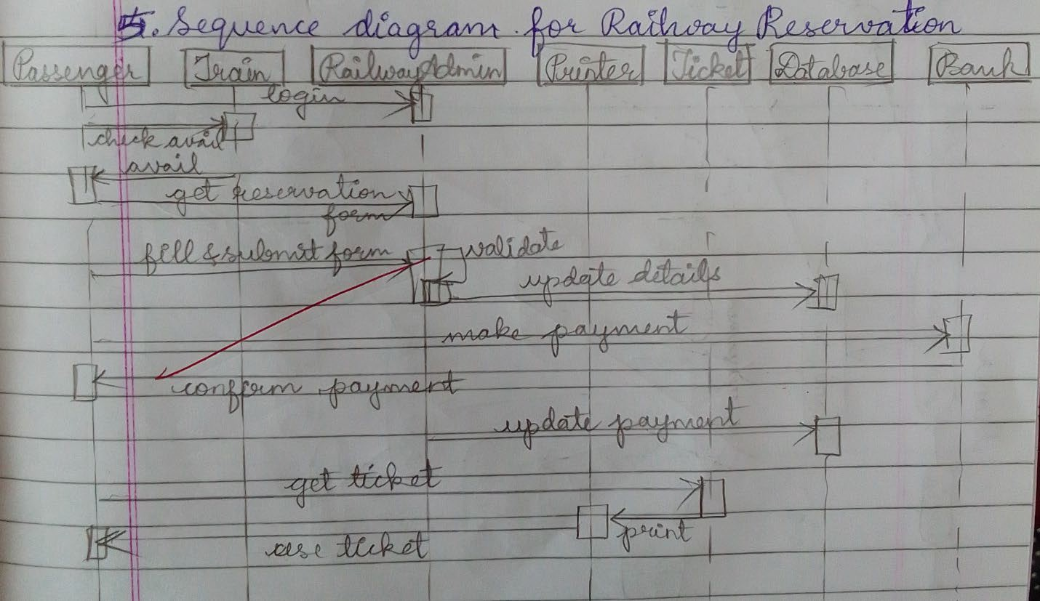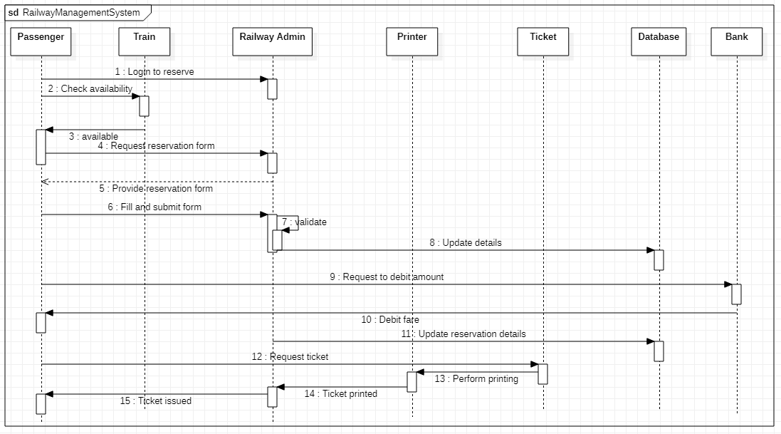

1. **Advanced Activity Diagram**

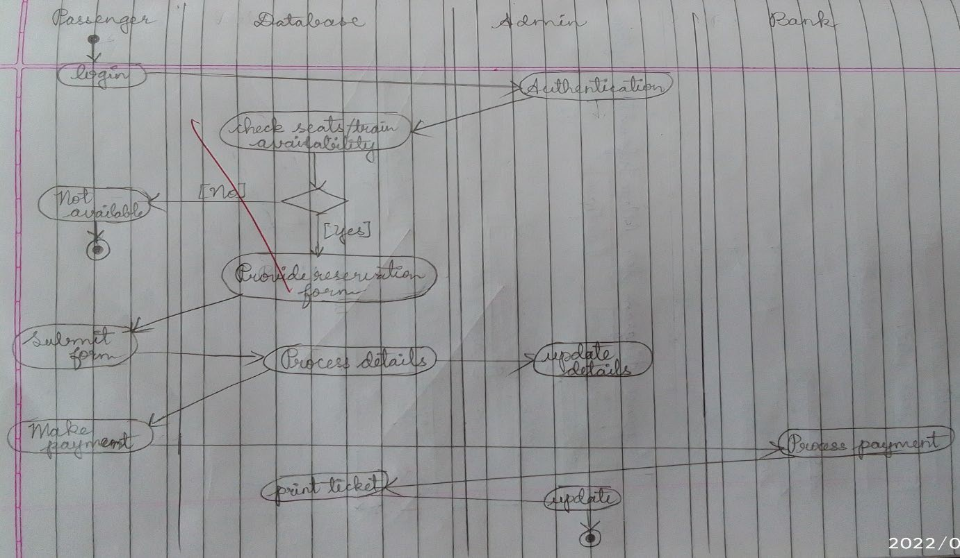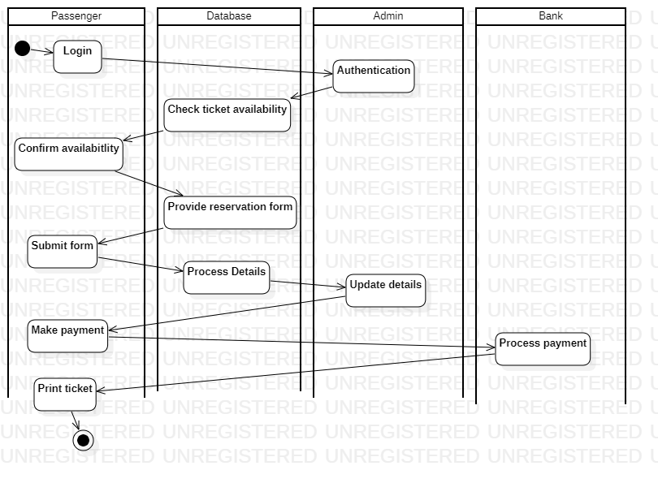

**Exercise 6- Graphics Editor**

# SRS

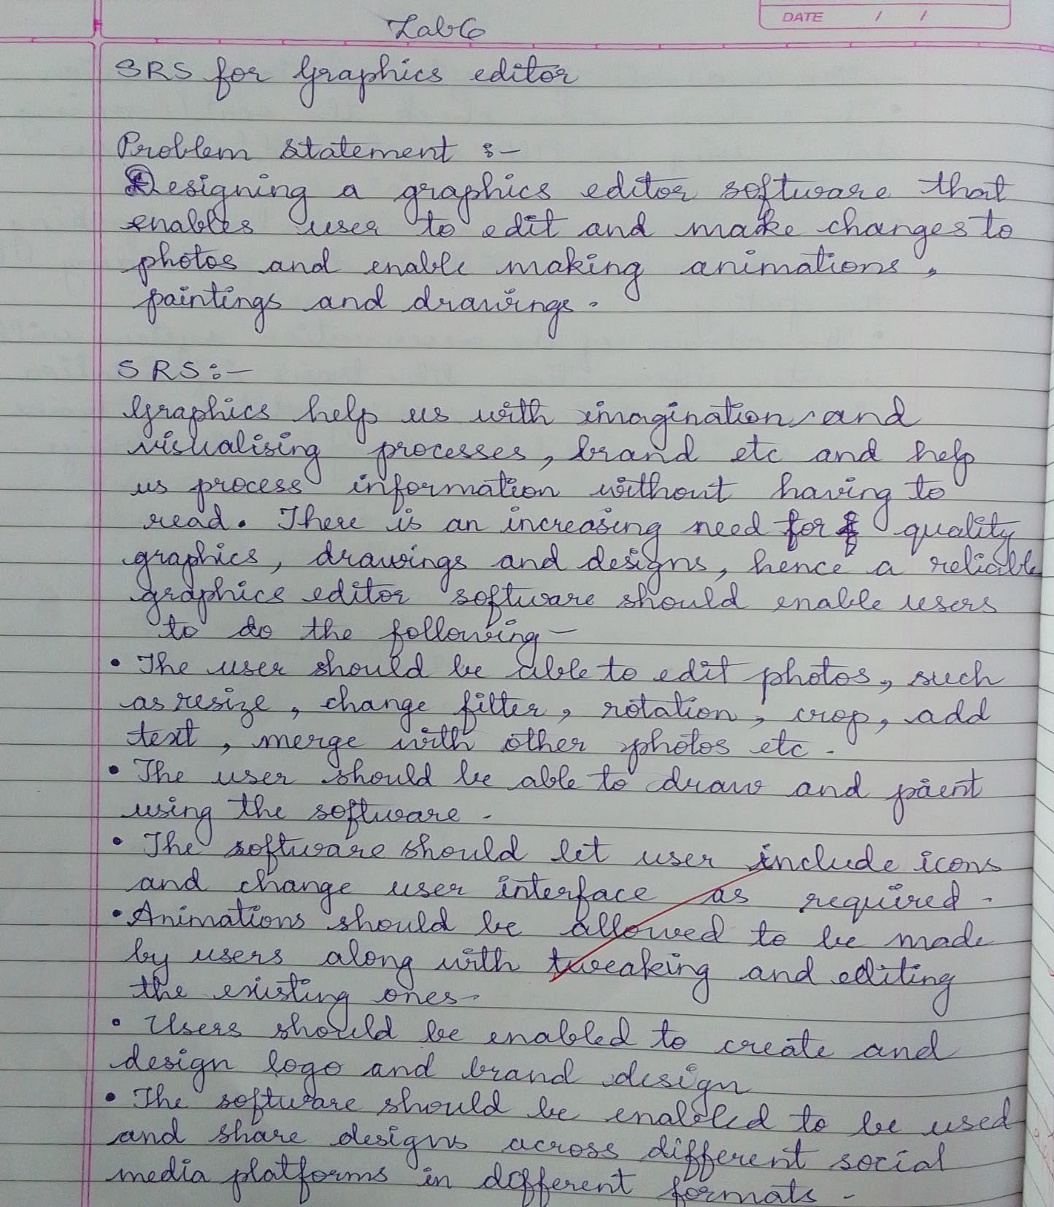

1. **Advanced Class Diagram**

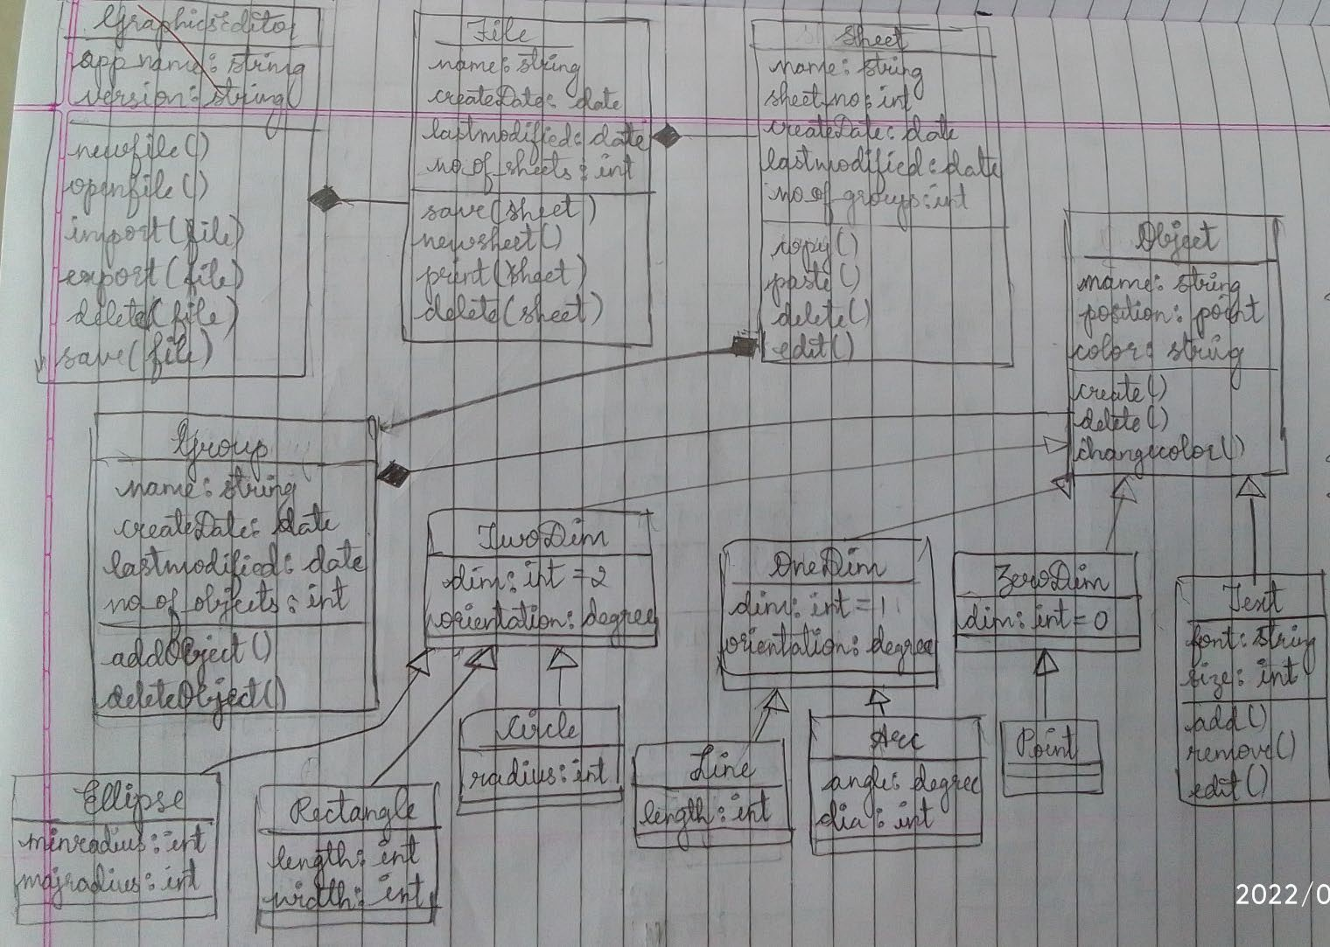

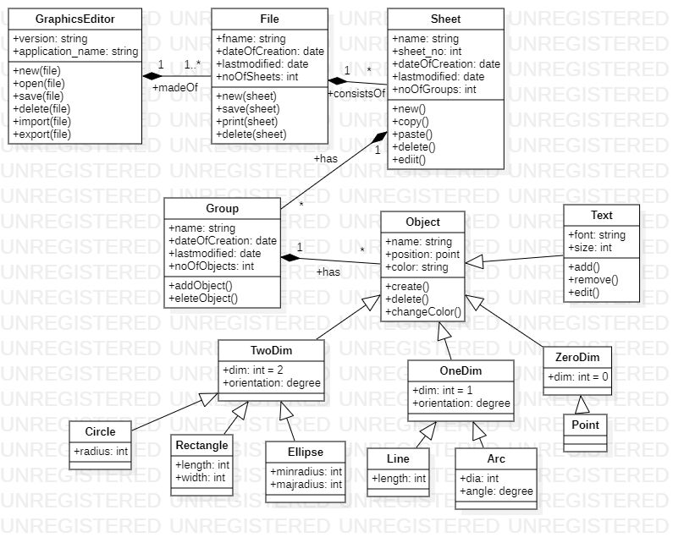

1. **Advanced State Diagram**

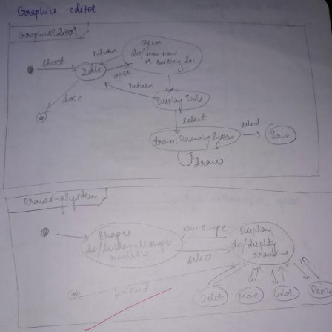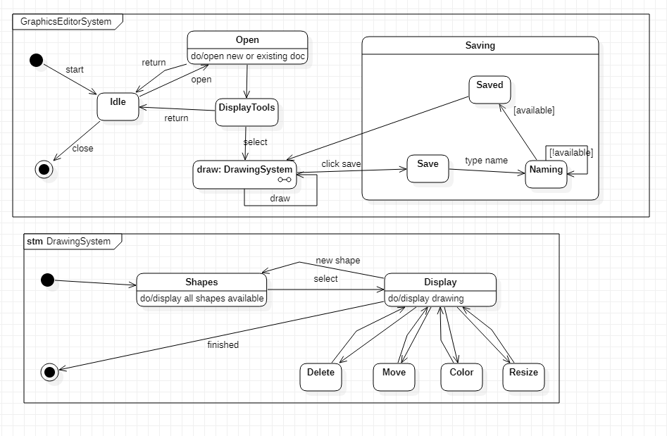

1. **Advanced Use case Diagram**

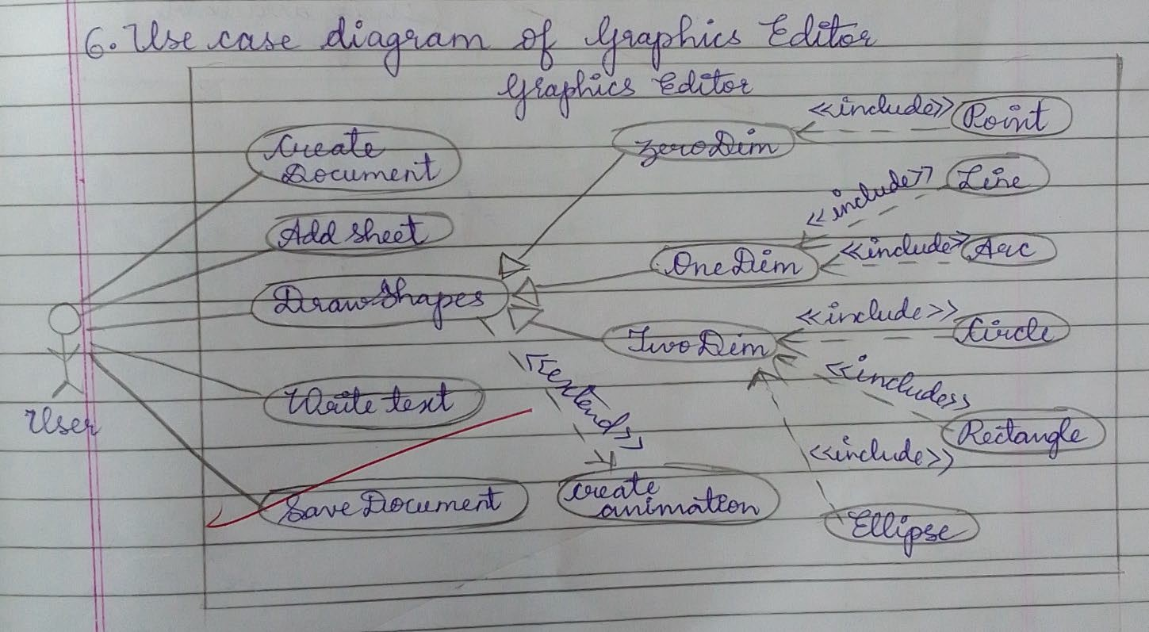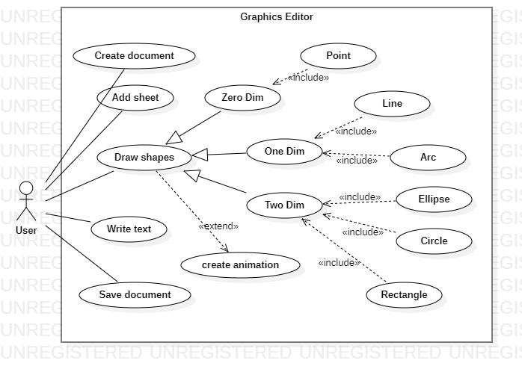

1. **Advanced Sequence Diagram**

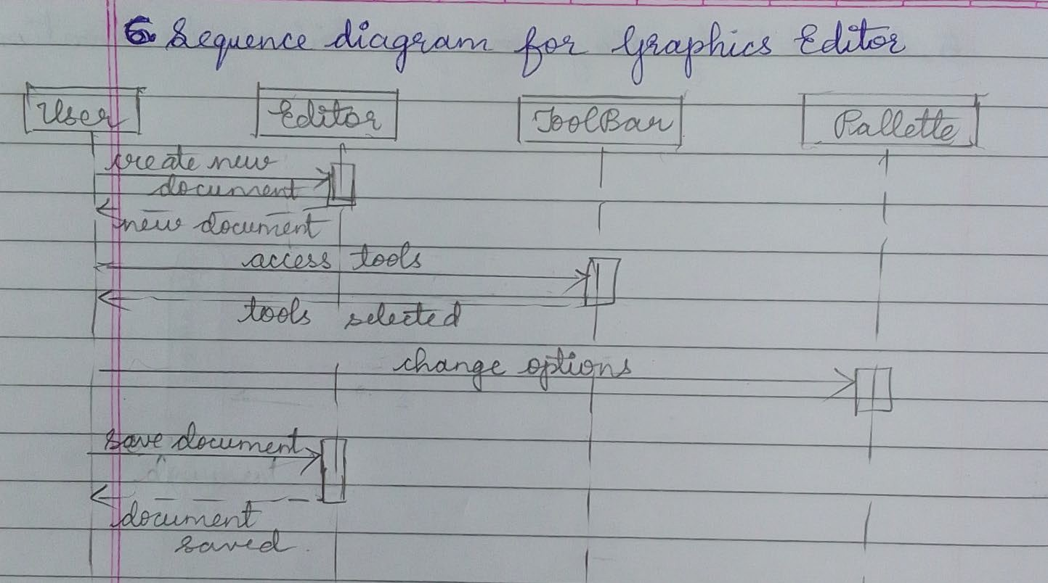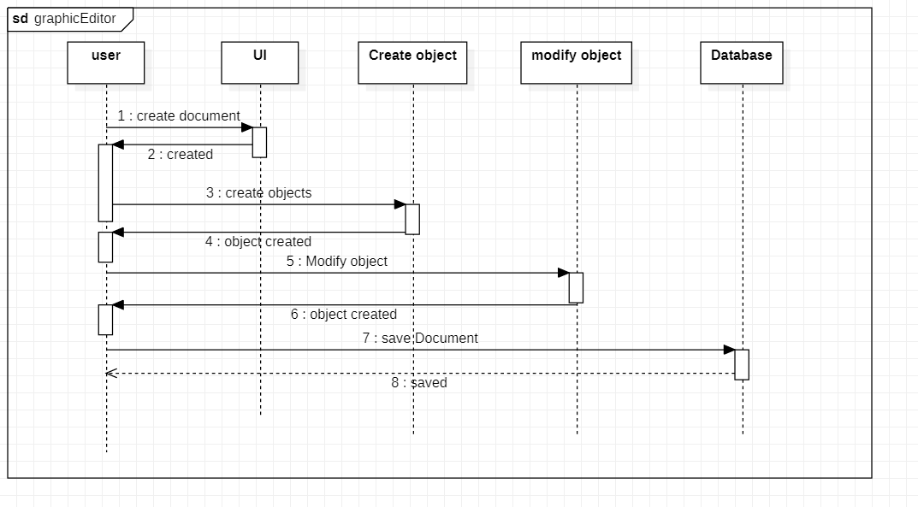

1. **Advanced Activity Diagram**

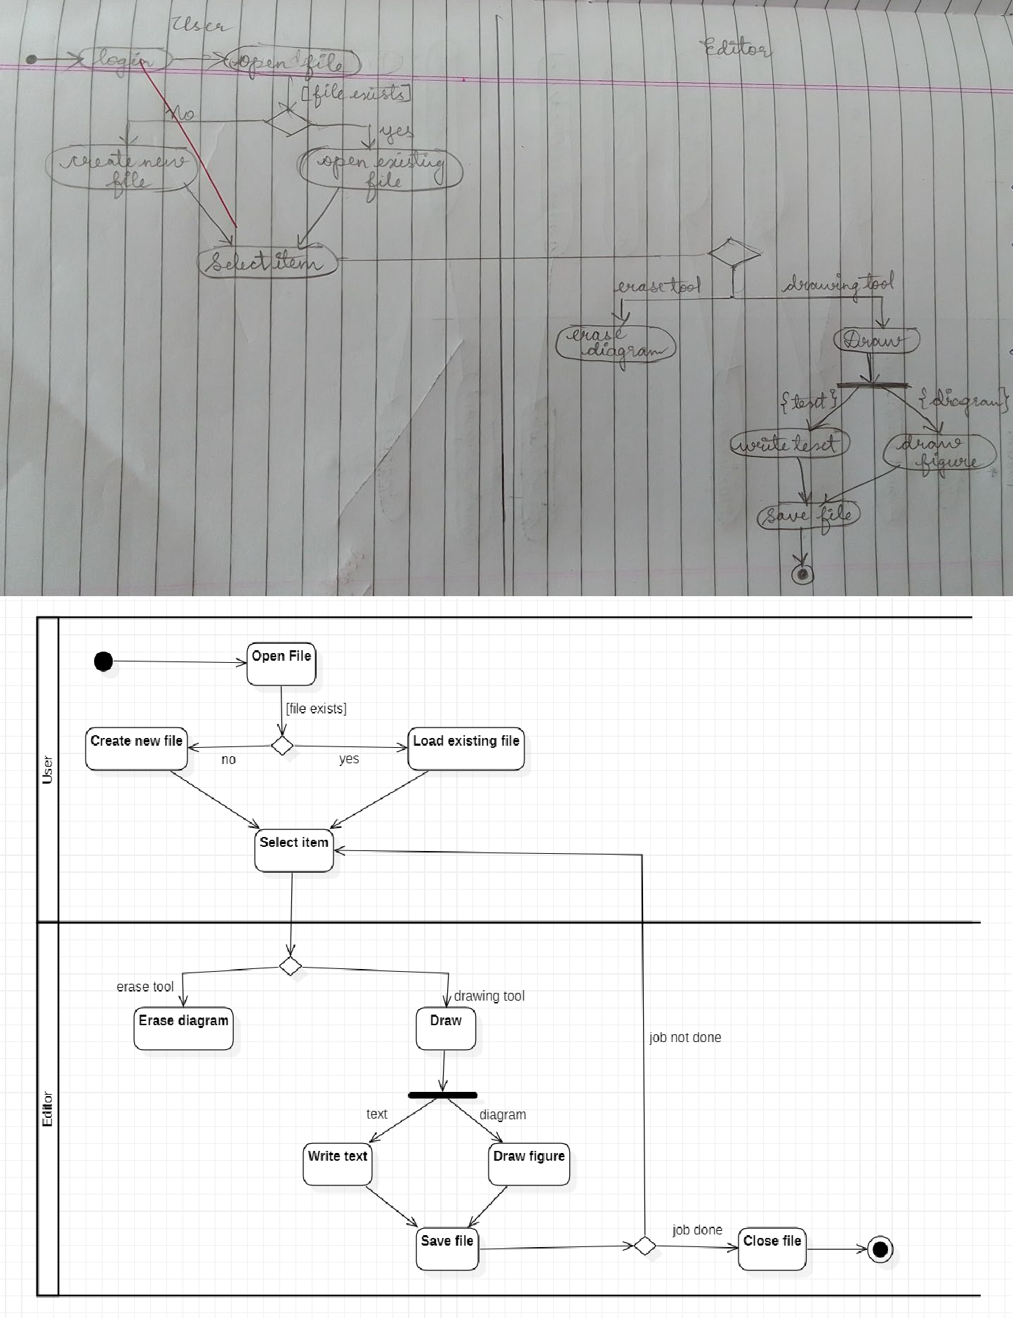

**Exercise 7- College Information System**

# SRS

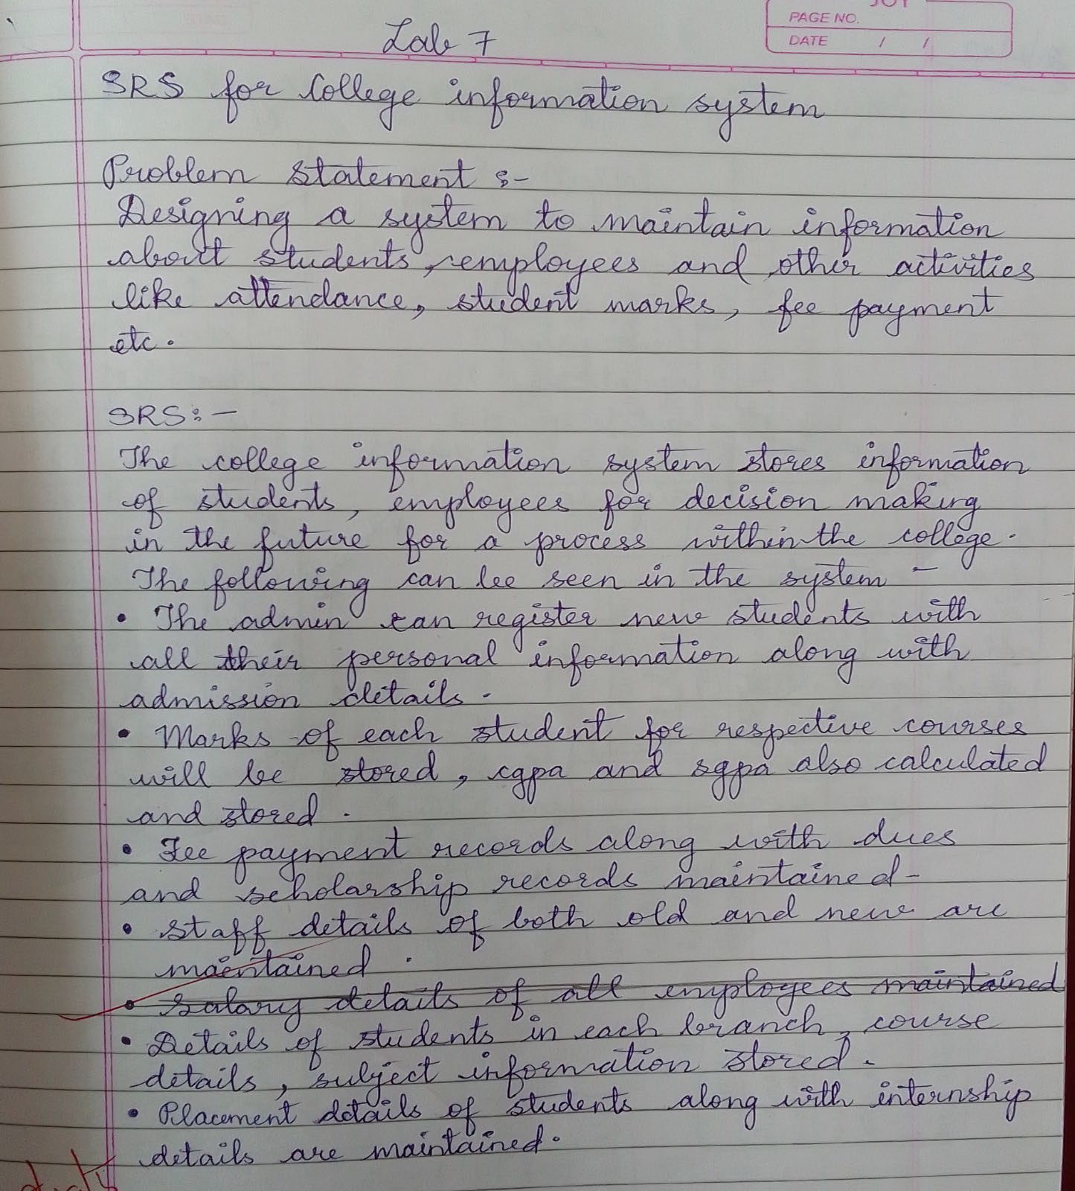

1. **Advanced Class Diagram**

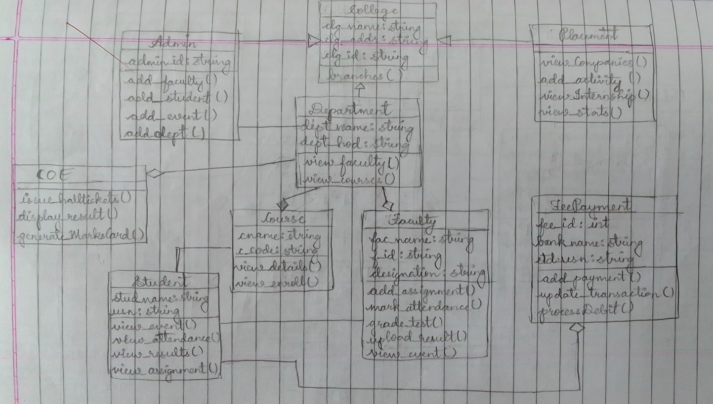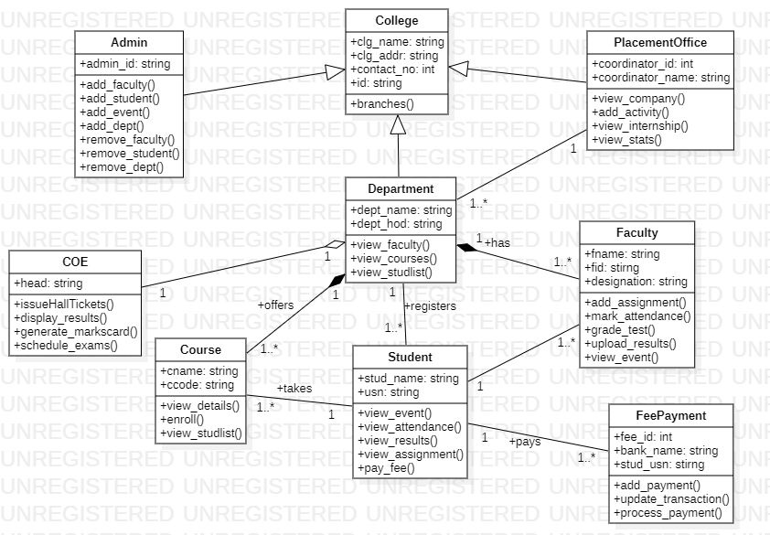

1. **Advanced State Diagram**

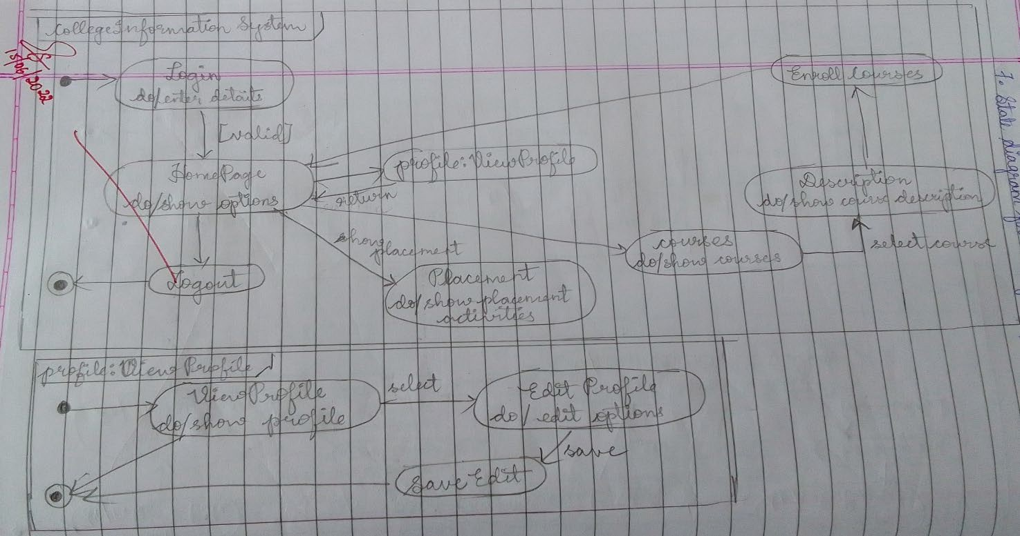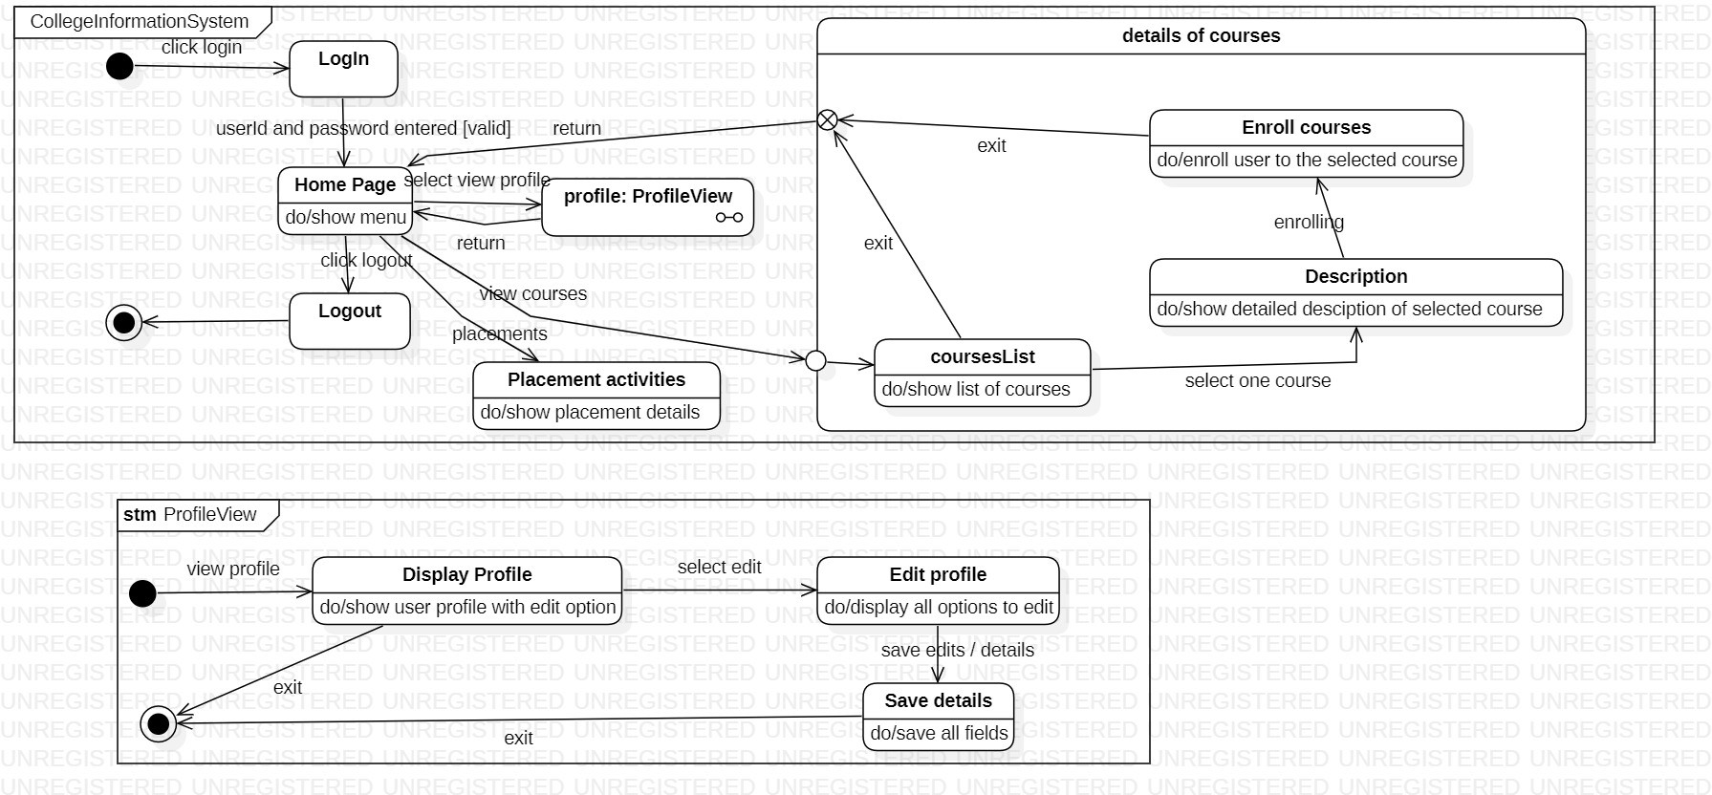

1. **Advanced Use case Diagram**

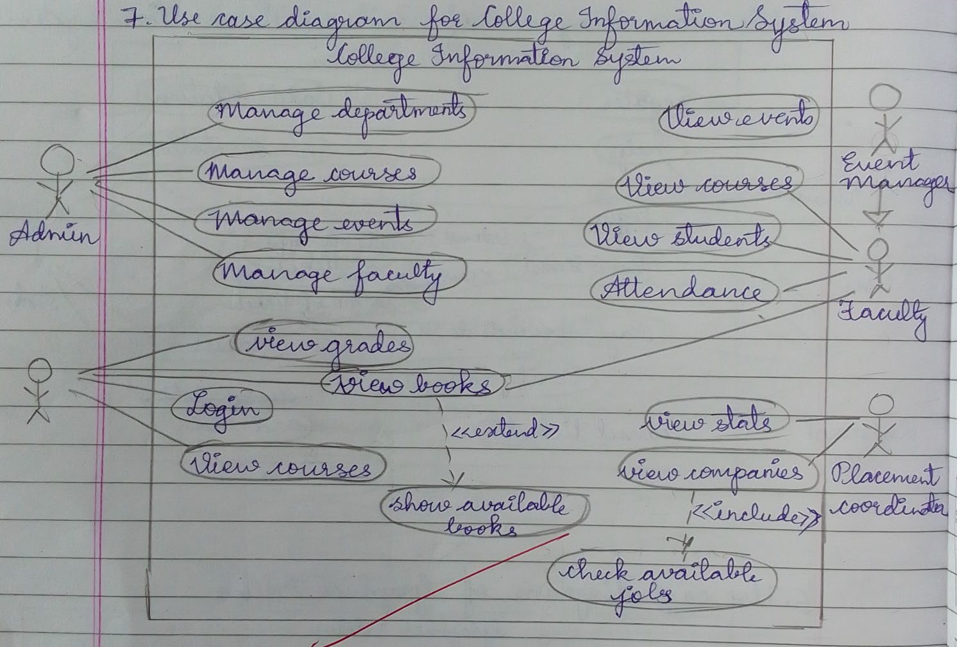

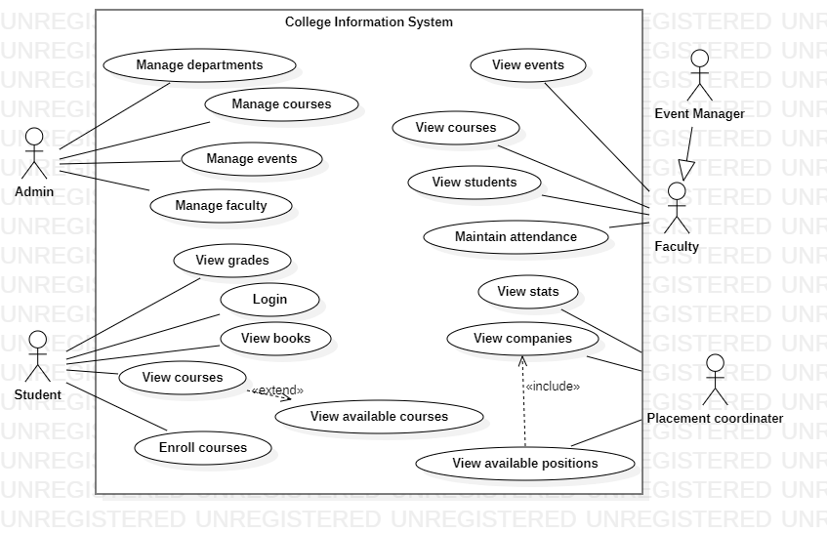

1. **Advanced Sequence Diagram**

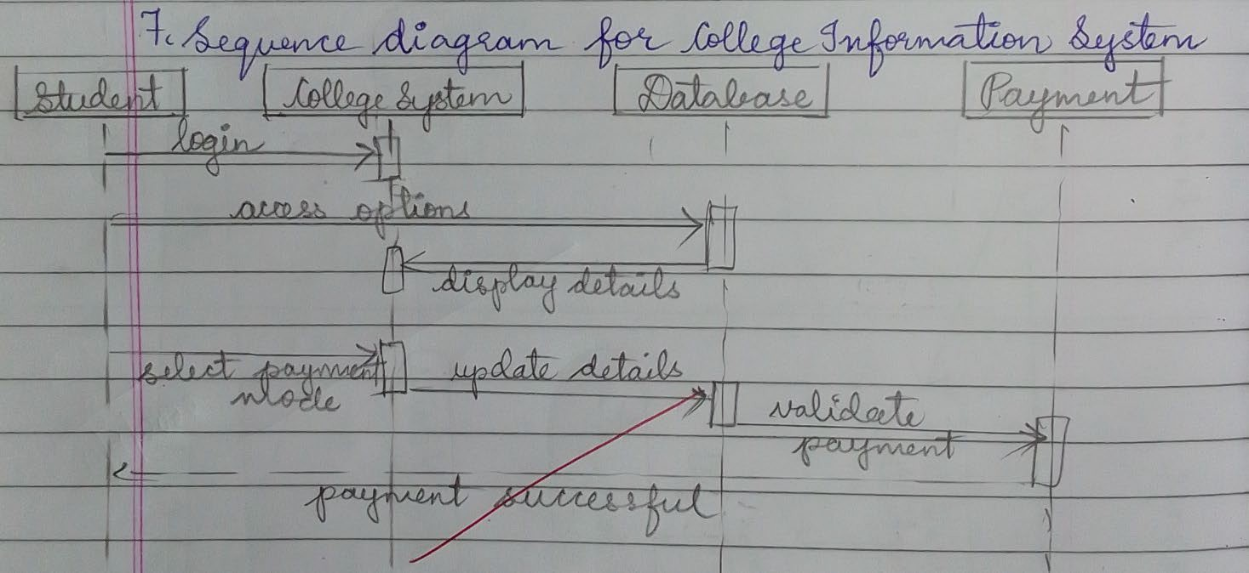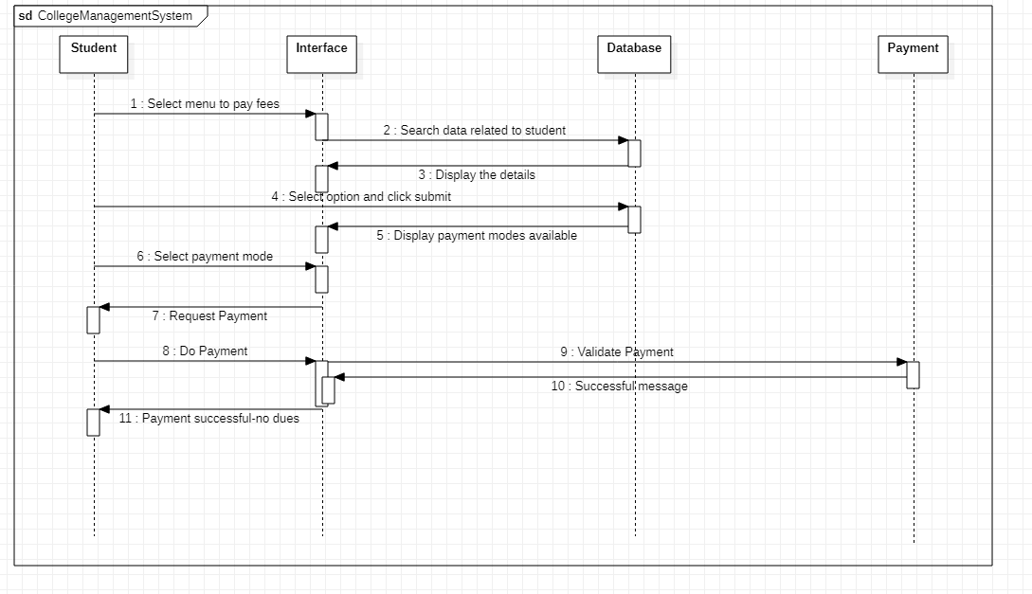

1. 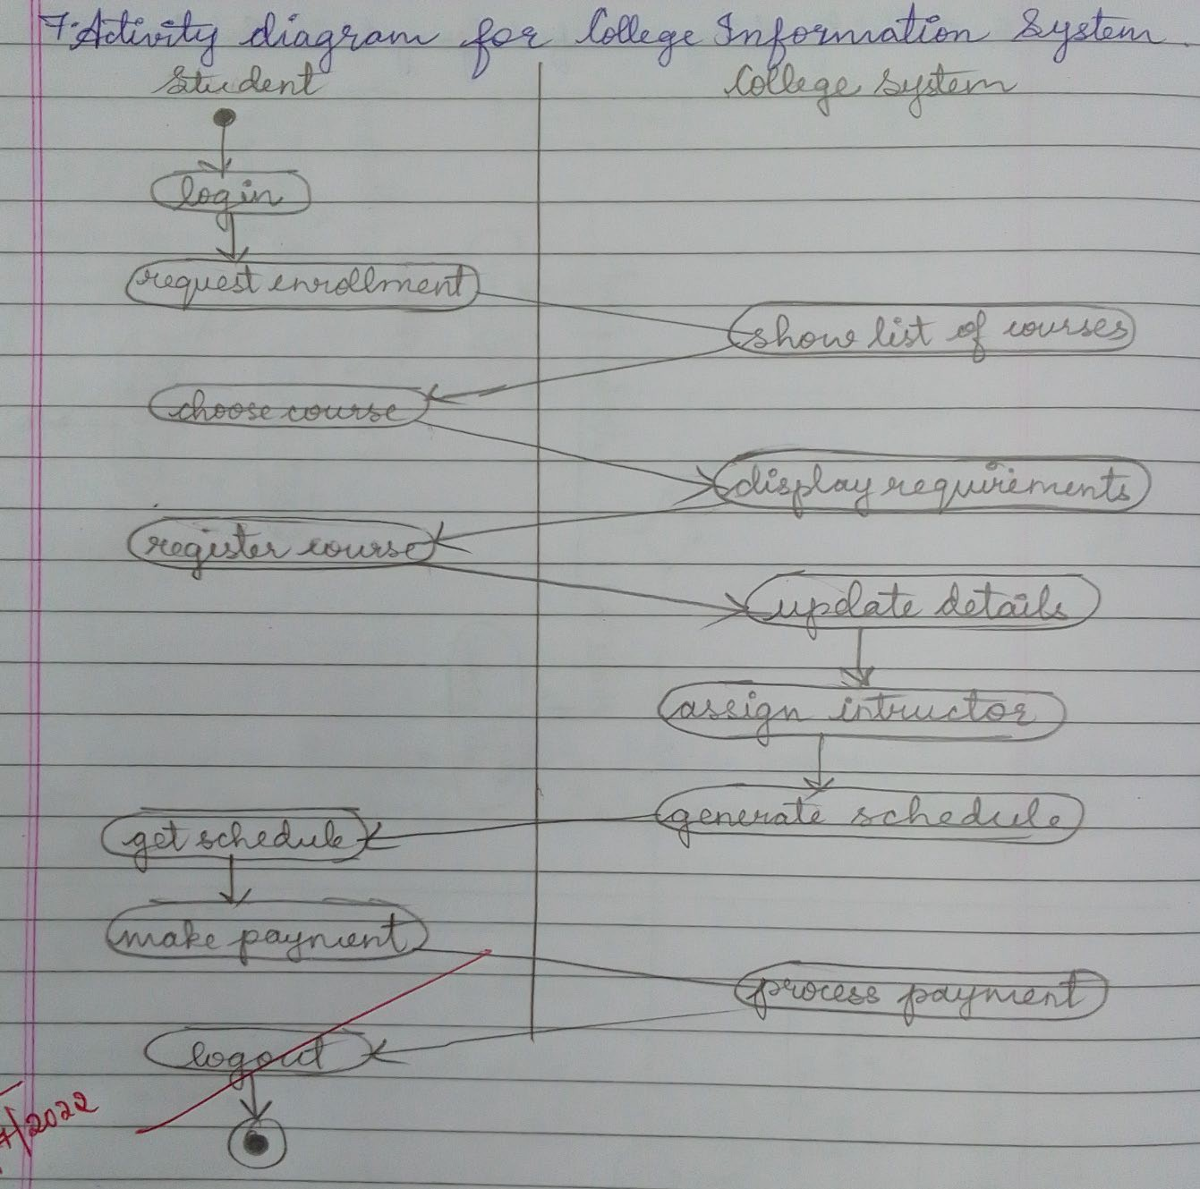**Advanced Activity Diagram**

